

**THE GRAPEVINE**

**Faith Lutheran Church**

**September 2017**

**4010 Williams Drive**

**512-863-7332 Georgetown, Texas**

**Website: flcms.org 78628**

**FOR ALL GENERATIONS**

*Jesus Christ is the same yesterday and today and forever.*

(Hebrews 13:8, NIV)

LifeLight: Exodus Part 1

Starting September 13, many of us will embark on an in-depth study of the book of Exodus, Wednesday nights from 7-8:30pm, using the LifeLight materials. And it will be spectacular! For those of you who have never studied the Bible before, especially the Old Testament, this would be a great introduction to Bible study done in community. The story of the Exodus, simply put, is nothing less than *The Gospel According to Moses*. You will be shocked at the extent of God's plan of redemption and how it all comes together in fulfillment in His Son Jesus and the implication for us today.

I say, you will be "shocked" only because the first time I studied Exodus (1996) I was simply blown away. I went into the study thinking that the Old Testament was, well, "Old." After all, that's what we call it, is it not? Why even bother studying something that is "old" that clearly cannot be applicable today? Did I not 1) learn the story of baby Moses and the basket when I was in Sunday School as a child? But of course. 2) Did I not memorize the Ten Commandments in confirmation? Certainly. 3) Learn about the Golden Calf? Absolutely! 4) Tabernacle? Uhm, well, I might have missed that one? I had tonsillitis a couple of times. 5) Covenant? What? Must have been out with a stomach bug that day. 6) God revealing His name? Seriously? That's in there? God has a personal name??? Why did no one tell me that? 7) Jesus? You have got to be kidding me. Jesus is in the book of Exodus?

A lot of people today still think that the God of the New Testament is now working and interacting with the world differently than He did in the Old Testament. The same God, if you will, but doing things differently in different times. In other words, you might hear someone say, "In the Old Testament, God dealt with people through the Law; and in the New Testament we have been set free from the Law and He only deals with us through the Gospel!" Shockingly, this is simply not the case. Our God is the same God both in the New Testament as in the Old Testament. What, then, does this mean?

Simply put, the Old Testament is not really "old" at all. In reality, it just happens to begin with "In the beginning," which reaches all the way back. The Old Testament is nothing less than the beginning of the one story of salvation. It is the foundation that God laid that led to the ultimate fulfillment of His plan - through Jesus Christ. That's why we can say, without reservation, that the Torah (first five books of the Bible) are in fact the Gospel of Moses. They are Moses' words, but they are all pointing ultimately to the fulfillment in Jesus Himself. And when you see that, in the Old Testament for yourself, you too may find yourself being "shocked" at just how amazing the plan of salvation really is.

So, are you wondering if you should study the Exodus with us? Perhaps this will help you answer that question. The central story of the first five books of the Bible is nothing less than the story of the redemption of the people of Israel from their slavery in Egypt and their establishment as the people of God. Ever wondered how we **become** God's people? Ever wondered how we **remain** God's people? Then an in-depth look, in community, of Exodus is most certainly right up your alley. Because here we are invited to see what God is going to ultimately do to redeem His people and how He plans on keeping them near to Him.

Sound exciting? Come check it out anytime throughout the quarter and see for yourself just how new the "old" Testament really is.

Shalom!

Pastor Bill Crowe

**Please join us for the**

**2017 Church Picnic**

**Georgetown Community Center, San Gabriel Park**

**11:00am- 3:00pm**

Wear your favorite picnic attire and Name Tag to worship service then head on over to the Church Picnic!

The Church is providing the meat from Smokey Moe’s BBQ, with

Potluck sides and desserts provided by the Congregation.

If your last name starts with A-L, please bring a side dish that serves 6-8

If your last name starts with M-Z, please bring dessert that serves 6-8

If you would like to bring a side and a dessert, please do!

Food sign-ups will be at the Ministry Center starting Sunday,

September 3rd

*Complimentary Coffee Bar Complimentary Beer*

*Provided by Community Coffee Provided by Rentsch Brewery*

Tea, Lemonade and Water will also be available.

**Youth Dessert Auction, 1:00pm**

Please come and show your love for our Youth by bidding on delicious homemade desserts. All proceeds will go towards their trip next summer to Glorybound2018!!

*The minimum bid for each dessert will start at $10*.

**Get Involved and Volunteer!**

If you would like to help out, we have many areas you can volunteer.

Contact Denise Barnes for more information

***Friends***Children’s Activities***Fellowship***Bingo with Prizes!***Fun***

Heartfelt stitchers.tiff

After a short break this summer, Heartfelt Stitchers will meet again beginning September 14th in the church library at 9:30 a.m.  We're gathering our yarns, hooks, and needles and are anxious to get back to work as a group.  Even though we haven't met together, we've all been busy with projects.  Pastor Pohland has given several of our blankets at baptisms this summer and we'll be ready to make a trip to Dell Children's NICU and to Wesleyan Hospice with more deliveries.

Please join us at 9:30 on Thursday mornings in the library.  If you have any questions please contact Sherry Craig or Sherry Richter. We'd love to have you join us!



Come meet our youth and bid on their delicious desserts at their Dessert Auction during the Church Picnic.

Proceeds from the Auction go towards the Youth’s trip to Glorybound 2018.

Minimum bids for each yummy dessert start at $10.00

Auction starts at 1:00pm

Contact Cassie for more information 512.863.7332.

Joy Mission Circle

Doesn’t “Back to School” Feel Like “New Year’s”?

Try something new…for this new school year, come see what goes on in Joy Mission Circle!

We would love to have you join us Tuesday September 5th at 6:30 pm in Room B116. We will have a short business meeting before our Bible Study. We are usually done about 8 pm, and meet the 1st Tuesday of the month (except for June and July)

Questions? Feel free to contact Joanna Roche.

**Military Care Support Ministry**

During the month of October, the Military Care Support ministry will be hosting a care package drive.  A barrel will be set up in the narthex for donations.  We are putting together snack bags for active and non-active military personnel at The ROCK in Georgetown.  We are asking for donations of the following: water bottles, Gatorade bottles, fruit bars, granola bars, energy bars, hard candies, peanut butter or cheese crackers, etc.  The snack bags will be delivered just prior to Veterans Day with a note of appreciation and thanks for their service.  If you have any questions, please contact Sheila Gauntt.

**CHRISTMAS IS COMING** and so is Faith’s annual Christmas Cantata!!  Practices begin on Thursday, September 21st at 7:00 P.M. in the Choir Room. All members who enjoy using their God-given singing ability, in His service and to His glory, are invited to join us. As in past years, there are no auditions. The Cantata will be sung twice at Faith: On December 17th at 8:30 A.M. worship and on December 31st, 2017 at 11:00 A.M. worship. If you have questions, please call Phyllis Draheim at 512-863-7332.

helping hands.TIF**Helping Hands Lutheran Women’s Missionary League**

Our next meeting will be on September 12 with Fellowship at 9:15. Lois Howe will be leading our Bible Study beginning at 9:30.  Our Bible Study is titled “The Profound Search for Wisdom” found on page 22 of Lutheran Woman’s Quarterly for Summer 2017.

We will once again be selling Christmas Cards on three Sundays:  September 10, September 17 and September 24.  We will also have birthday, get well, sympathy, etc. cards for sale. After you make your selection you will pay in advance and the cards will be available for pick up at a later date.

Our Mission for September is Jesus Is Lord and we will also be giving Faith Lutheran Preschool $200.  Quilting will continue to be on Tuesday mornings at 9:30am upstairs in the Activity Center on the 1st, 3rd and 4th Tuesdays.

We always welcome new members.

ALWAYS SHARING GOD’S GIFTS

“Let no debt remain outstanding, except the debt to love one another.” Romans 13:8a

Today I want to talk with you about the Always Sharing God’s Gifts campaign.

Always Sharing God’s Gifts is your program to raise the above-budget funding to retire the debt on this marvelous sanctuary.

First, Faith wants to thank you for your prayers and truly generous sharing of God’s gifts. Since we first built this sanctuary we have retired more than half of the debt.

Second, if you have recently joined us and want to participate, or even if you have been a member for a while and are now able to participate, it is not too late. See Pastor Pohland or Pastor Crowe or just drop a check with “ASGG” on the memo line into the offering plate.

Third, why this building and why this time? Recall the Great Commission:” Therefore go and make disciples of all nations.” Though we do not often think of this sanctuary as an evangelical tool, it is indeed.

How often has someone said to you, “Oh, that’s that pretty church on Williams Drive.” “Oh, I’ve seen that church when I drive out toward Sun City.”

It creates awareness. It helps us make a connection. It helps us spread the message. It might not be the noblest of motives to pick a church because it is pretty and air-conditioned, but Christ expects us to meet people where they are.

David Wright

Chairman of your Church Council

**Compass Ministry begins this month**

*Compass Ministry is our small group ministry at Faith; a network of small bands of believers living faith life together, called****Compass Groups****.*

*Compass Groups provide an excellent way to delve into God’s Word and develop meaningful Christian relationships. It is an opportunity to love and be loved within a caring group of friends who are also discovering what it means to follow Jesus. Compass Groups offer a safe place to learn how to minister to one another, discover God’s love for us through His written Word and have a great time in a relaxed and comfortable setting.*

*Currently, we have 16 Compass Groups (averaging 10-12 members) meeting on a regular basis at Members homes and church. Almost all groups take the summer months off and resume in September/October which means this a good time to join Compass Ministry. Some, but not all, existing groups are at capacity. We would love to see everyone who wants to be a part of this ministry be able to do so. Right now is an ideal time of the year to start the formation of new Compass Groups!*

*If you would like more information, please contact:*

*Peggy Hill, Compass Groups Coordinator.*

**BRAILLE WORKERS**

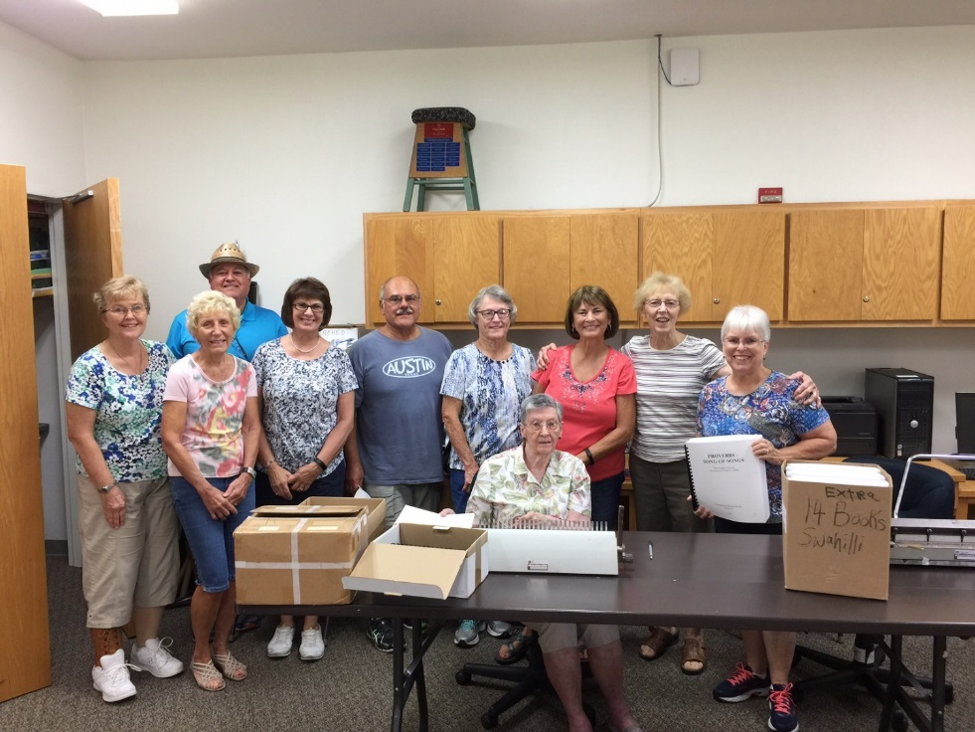

The Faith Lutheran Braille Team consisting of Mary Peck, Diane Huff, Frank Rauch, Jane Schmidt, Jim Mateos, Pat Priem, Julie Rauch, Lois Howe, Carol Hancock, and Moni Neeb (seated) pose for a picture after completing fourteen copies of PSALMS, PROVERBS AND SONG OF SOLOMON. Each nook is ninety pages and will be distributed to the blind around the world.

The Braille Team meets every second Monday of the month at Zion Lutheran from 1:00 PM to 3:00 PM. If you feel the Lord calling you to his important ministry, please call Paul or Lois Howe.

**HAPPY SUMMER!!**

**From the**

**Lutheran World Relief Quilters ……..**

Sharing some photos of what we’ve been doing upstairs in the “COOL” Activity Center

There are several steps in completing one Quilt.

Below you’ll see pictures of some of those steps.

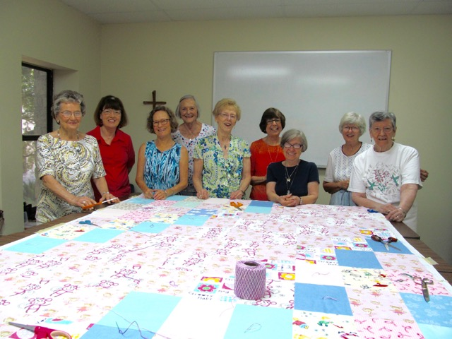

**The Knot Tying Group**

Left to Right:Pauline Flatness, Bonnie Kelinske, Linda Carter, Lois Howe,

Jeanette Frese, Marilyn Sterriker, Nancy Benkovic, Moni Neeb

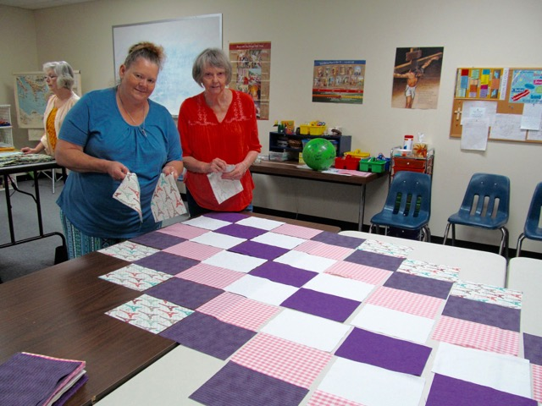

**We would love to have you come on up and join us on**

**Tuesday Mornings – 9:30-11:30 AM**

(Except the 2nd Tuesdays)

Two important steps are done at home …

Cutting the blocks & Sewing the blocks together.

(we’ll provide all materials you need)

**YOUR HELP IS NEEDED**

If you have any questions please call Gert at

**Laying Out Tops (Above)**

Mary Colburn and her daughter Heidi

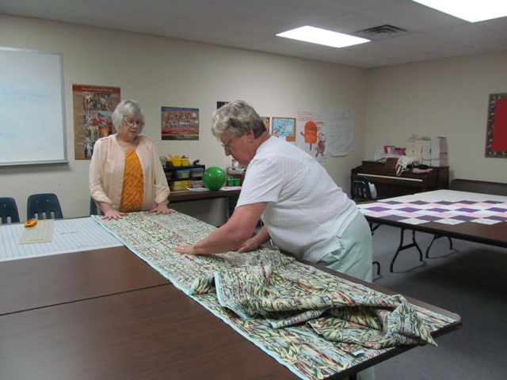

**Measuring Out Backs(Left)**

Left to right: Margaret Wachsmann,  Judy Prehar

**The Texas District Church Extension Fund**

To learn more about investing in CEF and make ministry happen, go to www.texascef.org, or call 1-888-951-1233, or call Calvin Spencer.



The current CEF investment rates are:

Flex Savings 0.500%

Fixed-rate notes - 1 Year 1.500%

Fixed-rate notes - 3 Year 2.000%

Fixed-rate notes - 5 Year 2.250%

Floating-rate notes - 1 Year 1.125%

Floating-rate notes - 3 Year 1.500%

Floating-rate notes - 5 Year 1.875**%**

**Cancer Now What?**

Almost everyone has had cancer touch their lives in some way…themselves, a loved one, a friend or a colleague. It can be a frightening time both for the person with cancer and their loved ones.

Stephen Ministries newest book, “Cancer Now What?” by Kenneth C. Haugk, Ph.D. became available this year. This book has been years in the making. Dr. Haugk wrote the book based on his own experiences of caring for others dealing with cancer and extensive research he gathered from more than 3500 survivors, loved ones, physicians and other medical professionals. He wrote the book to empower people dealing with cancer.

Our Stephen Ministry Team here at Faith Lutheran completed reading and studying this book together. It is a comprehensive, practical how-to guide to help cancer patients and loved ones navigate the medical, emotional, relational and spiritual challenges of cancer. The book is divided into 12 topical parts with 74 easy to read chapters. Some of the topics in the book include: Dealing with the emotional dimension of

Cancer, Working with and relating to your medical team, Defining and caring for yourself, Relating to others, and Spiritual Matters. One can skip around to read the material that is most relevant and useful at any given time.

**The Stephen Ministers at Faith will be hosting a book review of Dr. Kenneth C. Haugk’s latest book: “Cancer Now What?” We will present various parts of the book and you will have the opportunity to pre-order a copy of the book for yourself or a loved one.**

***Please join us on Sunday, Oct. 1st in B116 at 4:00pm.***

***Light refreshments will be served.***

Stephen Ministry is a one-to-one, confidential, caregiving ministry that provides distinctively Christian care. Stephen Ministers are highly-trained lay people who meet with their care receivers once a week. They listen, care, encourage, and provide emotional and spiritual support. The caring relationship lasts as long as the care receiver is in need. If you are hurting or going through a difficult time and need a listening, non-judgmental, caring ear and heart, contact the church office to ask for a Stephen Minister.

By Peggy Hill, Stephen Minister, Faith Lutheran Church

As Fall approaches, Faith’s annual stewardship campaign is also approaching. The concept of offering God our first fruits, our first and our best to God, is important since from those first fruits, God works for our good. This year, Faith examines **Living Christ** as a theme for our giving. Living Christ is never in isolation, rather in community. In that spirit, please consider how together we:

**… Worship.** Worship is such an important aspect of our faith lives and our life at Faith. 52 weeks of worship, 6 Lenten worships, 4 Advent worships, worship with our shut ins, 15 baptisms, and 12 confirmations last year all reflect how worship is central in Living Christ.

**….Send.**  Just as the early church spread from Jerusalem, to Judea, to Samaria, to the world, Faith goes to Georgetown, to Williamson County, to Texas, and to the World. Serving at the Caring Place, the Boys and Girls Club, helping train DCEs to be sent into mission fields, sending mission crews to Dallas, and sending quilts to Lutheran World Relief are just a few ways we send people into a world that needs the love of Jesus.

**…Pray.** Prayer is a powerful tool that God gives us. The weekly Prayer Warriors, the Good Friday Prayer Vigil, prayer quilts for those in need, and the weekly prayer list all focus Faith in a life of prayer.

**…Love.** *We love because Christ first loved us.* Our Rock House ministry, our hospital and shut in ministry, our monthly worship services for Alzheimer’s patients, handing out water bottles and carnations down on the Square at Valentine’s Day, and so much more show God reaching out through us to shower His love on everyone.

**…Care.** *Faith is blessed to be a blessing.*  Stephen Ministry, the grief support group, pastoral counseling, and the ministries of the Board of Human Care and the Board of Elders all serve to help care for our neighbors.

**…Study.** With 2-4 adult bible studies per week, confirmation classes, first communion class, 5 elementary Sunday school classes, 2 youth bible classes, midweek bible studies and 16 active Compass Groups, the study of God’s Word is celebrated at Faith. We study God’s Word for discernment, to strengthen our life of discipleship, and to grow in our relationship with God.

These are amazing fruits of the ministry, and these are not even close to all the wonderful fruits of ministry that are happening at Faith. You probably know ministries that have been missed or stories that can be shared. In October, we will hear three stories that reflect the fruits of the ministry of Faith. Our commitment to giving of our time, our talents, and our treasure are essential for these stories to happen. Please begin to prayerfully consider how you will support these ministries in the year to come.

By Eric Silber

Rehearsals for Faith’s handbell choir will resume on Tuesday evening, September 5 in the sanctuary. If you are an experienced ringer and would like to join us, please call Joyce Best at 512-917-6032 and let us know of your interest.  We look forward to another year of praising God through our musical gifts.

**Elderberries2.tiff**

Be joyful always; pray continually; give thanks in all circumstances, for this is God’s will for you in Christ Jesus. 1 Thessalonians 5:16-18 NIV

**The SENIOR SOCIAL GROUP** will meet at IHOP, 750 S. I-35 on Monday, September 18 for a 11:30 lunch/brunch/breakfast.   Limited to the first 24 to sign up in the Ministry Center Sunday Sept. 3 or 10.

TESS’ TIDBITS

The days dwindle down…

I’m sure I’ve told you before, probably several times, that I love to hear The Chairman of the Board sing September Song. I’ve always enjoyed Sinatra, I like his voice, the music is beautiful and September is my birth month. But it can bring a bitter-sweet feeling. A feeling of sadness. Another year of my life gone by. Much of the past looks so beautiful and the future so uncertain.

Both my little brother and I were born in September, but by the time our birthdays rolled around, Mother and Daddy were usually away teaching in one-room country schools and we were under the stern eye of Granny. Not that that cramped our style all that much. Our childhood was happy and largely carefree. We were not aware of the Great Depression. Life on the Old Homestead found a roof over our head, food on the table and adequate clothing. We were healthy. We didn’t want for what we didn’t have. We didn’t realize there was more. We ran and played and caught things. Lightning bugs, June bugs and box turtles were collectors items. While those carefree years appeared to stretch to infinity, they passed and September took on new meaning. School!

A big red tablet (was that an eagle or an Indian on the front?), yellow No. 2 pencils, maybe some construction paper, children’s scissors with the rounded tips and that blue bottle of white paste. And books!

How exciting! New clothes (mine were usually homemade, but Mother was an excellent seamstress. Some were remodeled hand-me-downs). I liked school and always liked my teacher. It was fun getting to know new children, those I didn’t already know from Sunday School. I envied girls with straight blonde hair in Buster Brown cuts. They could probably tap dance and had black patent leather Roman sandals. None of which I had. The boys always looked so handsome and mature. Probably because I was used to my little brother. Labor Day and the start of School marked Septembers of my childhood and adolescence. A busy, exciting time; a new adventure!

Frank and I were married on September 1st. Celebrating our anniversary and my birthday made September special. I looked forward to the celebrations but not to the passing of time. But, as the song goes, “You can’t have one without the other”! And time did pass. Living in the South, I always looked forward to cooler weather after scorching hot summers (before air conditioning). Most welcome! In the Northwest, there is a feeling in the air that sometimes comes in August, but always by September. It’s a feeling of the approach of Autumn. The days grow shorter, leaves start to turn, you just feel the change of season. And while I enjoyed it, it always made me a little sad. A longing for time to stand still.

And now that “I’m in the autumn of my life” – “the days dwindle down to a precious few, September November these precious days”...WAIT! WAIT! WAIT! God willing, I’m not going there yet! No, not just yet! September is fast approaching. September 1st would have been our 67th Anniversary. Sadly, Frank isn’t here to celebrate with me, but I give thanks for our marriage and the many happy (and the few not so happy) years we had together. September 14th will be my 85th Birthday. I won’t be alone and lonely. I’ll be with Bob and Judy at their cabin in New Mexico. I’ll see how my golf game at 85 is at 8,400 feet. We’ll laugh and celebrate being together in the cabin Frank and I helped build. The Aspen leaves will be turning. Fall is coming! And October will see me with Mike and Peggy, in our beloved Pacific Northwest, looking out my bedroom window at Mt. Rainier, spending a few days with Andrew and Valentina, great granddaughter Lana and new great grandson Daniel, and seeing Art and Barbara, whose friendship stretches back over the past 56 years. I look forward with eager anticipation to these visits with loved ones.

And, meanwhile, here in my new home I have wonderful examples of those who aren’t just biding their time and waiting. I play bean-bag-baseball with a 94 year old whose game is better than mine. I hurry down the halls behind my elders. I laugh with them at the movies, enjoy good conversation in the dining room. The days may dwindle down, but they aren’t spending their time bemoaning the fact. An important lesson in remembering that “This is the day that the Lord has made, I will rejoice and be glad in it”. We may not be promised tomorrow, but we have today. Thanks be to God!

Tess Todd 8-19-2017

** SEPTEMBER 21, 2017 **

**Senior Advocacy Group (SAG) Seminar**

**Legal Solutions For Mature Adults**

**(And Their Families!!!)**

**Charles Lance, Elder Law Attorney**

Providing clear guidance regarding our decisions for handling our affairs in the event of incapacity or death can be a remarkable gift to spouses, children, and family members. Legal assistance in planning and document preparation is essential to ensure our wishes are carried out.

On September 21, Charles Lance, an elder law attorney here in Georgetown, will provide a broad overview of the preparations necessary to establish legally binding documents for exercising our wishes in the event of incapacity or death.

Our September 21 seminar will be held in Room B116, and we will have light refreshments and social time starting at 9:30 AM with Mr. Lance speaking at 10 AM. We are again inviting our friends at Zion, as well as other local churches, and we anticipate a large crowd for this outstanding opportunity to hear Mr. Lance speak on this remarkably important topic.

Our October 19 SAG Seminar will feature Mr. Paul Yura, National Weather Service Severe Weather Warning Meteorologist, speaking on Severe Weather Forecasting & How Seniors Can Prepare. This seminar will be entertaining and educational and will contain some outstanding color graphics and video.

**ATTENTION, SCRIPTURE READERS!**

**What Is A Scripture Reader? A scripture reader is a person who reads scripture lessons at worship. Public scripture reading is an important ministry as the reader becomes a vehicle for sharing God’s word with the congregation.**

**Who Can Be A Reader? Anyone who has the gift and commitment to read. This is a very practical way to invite people to become more involved with their church. If you are able to read clearly, and are interested in being a part of this ministry, then please complete the application below and place it in Mail Box #422, email it to** [**j9andken95@suddenlink.net**](mailto:j9andken95@suddenlink.net) **or call Janine Alford at 868-3321. Even though you may have signed a form for this year, we still need to have one filled out for 2018 if you are interested in reading in the new year. For those of you who have not yet attended a scripture reader meeting, you will be notified as to when that will occur in the new year.**

**A schedule for the 2018 scripture readers will be published before the end of this year. You will also receive a copy of the bulletin from the church office a day or two before your scheduled date to read so you can review the scripture reading.**

**I would like to read the scripture at the following service: (circle one) 8:30 11:00**

**What month/s would you like to read during 2018? (circle three) January February**

**March April May June July August September October November December**

**Name: ______________________________________ (please print) Box #: _______________________**

**Email: _______________________________________ Phone #: _____________________________________**

**Comments: ___________________________________________________________________________________**

**__________________________________________________________________________________________________**

SUMMER IS ALL MOST OVER AND THE FAITH OWLS WILL BE RETURNING TO THE ROOST SUNDAY SEPTEMBER THE 10th

The Faith's OWLS (Older Wiser Lutherans) will meet Sunday September the 10th in room B116from 6:00 pm to 8:00 pm to enjoy an evening of Christian fellowship, fun, food and games. Host for the evening will be Jo Ann and Bill Sheaffer and we will be playing the domino game ‘Mexican Train’. Bring a snack to share; coffee and drink will be provided. Invite your OWL friends to join you.  
 If you have any questions please contact the OWL's coordinators

Bill Sheaffer or Jo Ann Sheaffer