**THE GRAPEVINE**

**Faith Lutheran Church**

**October 2017**

**4010 Williams Drive**

**512-863-7332 Georgetown, Texas**

**Website: flcms.org 78628**

**FOR ALL GENERATIONS**

*Jesus Christ is the same yesterday and today and forever.*

(Hebrews 13:8, NIV)

On the last day of this month, Christendom will observe the 500th anniversary of the Protestant Reformation. It was on October 31, 1517, that Martin Luther posted his “95 Theses” on the doors of the Castle Church in Wittenberg. His timing was not accidental. The next day, November 1, was a high holy day, All Saints’ Day, and it was expected that on that day crowds of Christians would assemble for worship, passing through those doors to join in praise of the Triune God Who bound all Christians together into one body, poured spiritual gifts onto each of its members, and promised them all places with Jesus in heaven. Luther was not disappointed. His theses were read by many and unleased a movement that still impacts lives and souls half a millennium later.

While the “95 Theses” are justly famous and remain worthy of study, it is his *Small Catechism* that is probably Luther’s best known and most wide quoted writing. In it, like other teachers of the faith before him, Luther presented Christian doctrine in parts. For him these parts all revolved around the central truth that sinners are saved from death and hell by no work or merit of their own but purely and wholly by the work of Jesus on the cross. The faith that clings to Christ is a gift from God Himself, bestowed by the Holy Spirit apart from any choice of human will or discovery by human intellect. For Luther, this truth of “salvation by grace through faith for Jesus’ sake” was both divinely revealed in Scripture and was essential for all orthodox understanding of what he called the six “Chief Parts” of Christian teaching, which he identified as the Ten Commandments, the Apostles’ Creed, the Lord’s Prayer, Holy Baptism, the Office of the Keys (Confession and Absolution,) and Holy Communion. So “chief” were these parts to the world’s salvation that Luther preached on them regularly throughout his career; and so important was a right understanding of them that even late in his life he studied the catechism daily and urged others to do the same.

To aid heads-of-house in their responsibility to teach the “Chief Parts” to their households, Luther did two innovative things beside preaching: He explained the parts in simple, easily memorizable language, and he set them to music as hymns for daily singing during morning and evening family devotions and in weekly congregational worship services. We will include a number of those hymns when we gather at 7:00pm, on Tuesday, October 31, 2017, for:

*The Catechism in Song: Singing the Six Chief Parts*

*Commemorating the 500th Anniversary of the Reformation*

Professor Joshua Chai, from Concordia University—Texas will serve as guest organist for this special observance. Please invite your friends to join us—not to look back on history in any kind of prideful nostalgia but to build on it with evangelical faithfulness as we strive in the present and toward the future to “make disciples of all nations” with the full assurance of an eternity guaranteed to the Church by the once crucified but now risen and soon returning Lord Jesus Who is “the same yesterday, today, and forever.”

Prayerfully, Pastor Walt Pohland

The 95 Theses

Five hundred years ago, a young man named Martin Luther kicked off what is now famously known as "The Reformation." On October 31, 1517, Luther posted 95 Theses (95 statements of Church belief and practice) that he believed needed to be addressed. Interestingly enough, no one really knows if Luther actually nailed his 95 Theses to the door of All Saints Church in Wittenberg (it was the university custom for beginning a dialog). What we do know is that he distributed them widely to his colleagues asking them to debate the issues with him.

The main topic that the theses pick up is the sale and use of Indulgences. An Indulgence, according to the Google dictionary, is "a grant by the Pope of remission of the temporal punishment in purgatory still due for sins after absolution." In other words, if a person needed forgiveness, he or she could now purchase an Indulgence as a way of demonstrating the genuineness of his or her confession and desire for absolution. As you would expect, this became a "hot commodity" throughout the German territories. People were lining up in the Church vestibules to purchase Indulgences.

What is perhaps most striking about the 95 Theses, however, is that if you read the document you probably will not be that impressed. Even by the standards of Luther's day, he was not addressing a perceived issue that the people were overly concerned about. On the contrary, the people rather liked the idea of an Indulgence. Honestly, it’s hard to imagine anyone in Luther’s day thinking that this document would set off a reformation.

If that is the case, why, you might ask, did Luther choose to go after Indulgences at this time in this way? The answer really shouldn't surprise us. Luther went after Indulgences because they were threatening the faith of the people in Wittenberg. He was concerned first and foremost for the people. Luther, after all, was *a pastor* who was also a professor. This was not academic to him; it was pastoral. Luther as a pastor was always concerned about salvation. And that, addressing the true issue of the Gospel of salvation (which Indulgences highlighted), is what kicked off the Reformation.

If you are now so moved to read the 95 Theses, I’ve included below some highlights to help you along. You can find them online, in English, at <http://www.luther.de/en/95thesen.html>.

Highlights from Luther’s 95 Theses

**Theses 1-2**

* Luther critiques how Indulgences were being handled. What was being said was not what Jesus would ever have done (the original, what would Jesus do).
* The clergy were teaching that Jesus came to deliver the sacrament of penance; Luther understands that the word "repent" is not this.
* Luther went back to the Greek and pinpointed the error. The Church had been using the Latin translation and understood it as “a sacrament of penance.” In the original Greek, however, Luther saw that it really was talking about a “life of penance.”

**Theses 6-7**

* Luther distinguishes between the Pope being able to forgive and where pardon really comes from (only God can forgive sins).

**Theses 9-19**

* Luther makes the case that forgiveness in purgatory (after death) is not biblical.

**Theses 40-49**

* Luther makes the case that Indulgences completely undermined the Christian life.
* Instead of looking for good works to do, they were looking for money to purchase these Indulgences.
* In thesis 49, he points out that Indulgences were deadly if the people were relying on them.
* He goes so far as to say that if you are relying on Indulgences, you probably are not a Christian.
* These theses completely undercut the Indulgence sales - how can you sell something that people are going to rely on, if they can't rely on them?
* This also called into question the authority of the Pope.

**Theses 50-51**

* Luther moves on to actually criticize the Pope.

**Theses 81-95**

* Luther now makes the move to ask the real question, if the Pope can sell Indulgences and offer forgiveness, why does he not just go ahead and redeem everyone from purgatory instead of building St. Peter's?
* Luther ends his theses by looking to the One who truly can save, to Jesus Christ
  1. Christians should be exhorted to be diligent in following Christ, their Head, through penalties, death, and hell.
  2. And thus be confident of entering into heaven through many tribulations rather than through the false security of peace (Acts 14:22).

And on that note, God miraculously used Martin Luther, and a seemingly unimpressive document, to kick off the Reformation. From that moment forward, God had all eyes following Luther's lead of looking to Christ and the Gospel for true confidence in salvation. To that I simply say, thanks be to God for all "reformers" who bring us back to the true saving work of our Lord, who suffered death on the cross and rose again from the dead for me (and for you).

To God be the glory!

Pastor Bill.

helping hands.TIF**Helping Hands Lutheran Women’s Missionary League**

Along with the items donated from our Church to the Hurricane Harvey Relief our Helping Hands Quilting Group donated the 68 quilts we had completed this year. We pray the recipients will find peace and comfort in these quilts.

The LWML Sunday is October 1 and our members would be happy to tell others about our group. The Capitol Zone Rally is also on October 1 at St. Paul, Austin.

We will once again be taking orders for our homemade cookies. The proceeds from the sale of these cookies are for our Missions.

Our Mission for October is Hope Alliance (formerly Williamson County Women’s Shelter).

Lois Meinke will be leading our Bible Study for our October 10 meeting found on Page 20 of our Lutheran Woman’s Quarterly for Fall 2017. It is titled Set Your Minds on Things Above beginning on Page 20.

**The Texas District Church Extension Fund**

Is a “Flex Savings” account right for you? Here are the Flex Savings benefits:

- $10.00 minimum to set-up the account,

- Great short-term investment,

- Very competitive interest rates,

- Add or withdraw funds at any time, without penalty,

- Your Texas CEF investments provide loan funding for LCMS congregations in Texas,

- Online access available through “My Texas CEF”,

-View your account information from home or office,

- Free Electronic Funds Transfer (EFT) between Texas CEF and your bank account,

- Set up a recurring EFT for automatic savings,

- Save for an emergency fund, college expenses, property taxes, auto-insurance fees, or retirement

To learn more about investing in CEF and make ministry happen, go to www.texascef.org, or call

1-888-951-1233, or call Calvin Spencer.

The current CEF investment rates are:

Flex Savings 0.500%

Fixed-rate notes - 1 Year 1.500%

Fixed-rate notes - 3 Year 2.000%

Fixed-rate notes - 5 Year 2.250%

Floating-rate notes - 1 Year 1.250%

Floating-rate notes - 3 Year 1.625%

Floating-rate notes - 5 Year 1.875**%**

**Military Care Support Ministry**

During the month of October, the Military Care Support ministry will be hosting a care package drive.  A barrel will be set up in the narthex for donations.  We are putting together snack bags for active and non-active military personnel at The ROCK in Georgetown.  We are asking for donations of the following: water bottles, Gatorade bottles, fruit bars, granola bars, energy bars, hard candies, peanut butter or cheese crackers, etc.  The snack bags will be delivered just prior to Veterans’ Day with a note of appreciation and thanks for their service.  If you have any questions, please contact Sheila Gauntt.

Spotlight on Compass Group Ministry

*For the next several months, this spot in our church newsletter will be highlighting various Compass Groups at Faith Lutheran. Each Compass Group Leader has been asked to write a brief summary about their group to share with the congregation. This month, you can read about the history of how Compass Group Ministry began with the Mickan Compass Group written by Curtis Mickan*.

**The Mickan Compass Group**

In early March of 1997, Marilyn and I met with Pastor Selle to receive permission to start an in-home Bible Study Group. Pastor Selle, being extremely interested in Bible Study, thought it was a great idea. After Pastor was made aware of our starting the Compass Bible Study program at Zion Lutheran in Dallas at the beginning of 1967 under the leadership of Pastor Dr. Carl Gaertner, he was very excited with the suggestion. While at Zion, God blessed the formation of 19 in-home Bible study groups along with 5 bible study groups that met at church within seven years.

As Marilyn and I had assisted organizing Compass groups at Zion Dallas, Pastor Selle strongly suggested that we take on the responsibility of Compass Bible Study Groups at Faith Lutheran. Additionally, Pastor suggested our new DCE, Becky Krentz, become involved with planning and implementing the program. Becky was a natural. With her God given leadership ability and Marilyn’s interest in recruiting members under God’s great guidance, we were on our way. Faith Group Ministry began in September 1997 with commissioning of leaders on September 14th. Curtis and Marilyn Mickan, Mike and Denise Barnes, Carol Willoughby, Susan Birchfield, Paul and Becky Krentz attended the first Monday night training along with Al and Karen Taylor who met with Becky on Saturdays. The Bible Study group grew to 24 members and kept growing. When we reached 30 members, Becky suggested splitting the members and starting another group which they continue to still lead. Our group has been blessed with professional lay people, retired Pastors and Educators to teach the Bible Studies. This has been an extra blessing to the group.

Today, with the blessings of God, Faith has around 16 in-home Compass Groups. A few of these meet at the church.

I would encourage you to consider starting new Compass Groups with members in the congregation along with their friends that need to be involved with Bible Study. The rewards are great! Faith is blessed with members that enjoy studying the Bible. Thanks be to God!

-Curtis Mickan

**“Anytime you study God’s word it is enlightening, rewarding and satisfying.”**

Karen and Al Taylor became leaders of one of the first Compass Groups at Faith. They also Coordinate the seven Sun City Compass Groups. Al and Karen are current members of Sun City Compass Group #8 (CG#8) which is the 2nd group that you can read about this month. Troy Pennington expressed the following information about CG#8.

CG#8 meets the 1st and 3rd Sundays of each month starting in the fall and concluding before the onset of summer. While Troy and Marilyn Pennington serve as Administrators for the group, various members

take turns facilitating the monthly lesson. They enjoy rotating their monthly meetings in one another’s homes.

Over the past few years, the group has focused on studying books of the Bible. Recently, they finished a study on Revelation which they found interesting and informative. The group begins a study on the book of Joshua this month. Troy states: “Getting to study the various books in the Bible has been great. Reading the Bible is one thing…but reading, answering questions, discussing these questions with others, and trying to better understand the history and present day applications have been most rewarding.” To enhance everyone’s study time, Troy collates the appropriate Bible Verses for each lesson and sends them to everyone as a study aid.

Being in a Compass Group also means time for fellowship and deepening relationships between members of the group. It is an opportunity to meet neighbors and fellow church members. One of the group's fellowship traditions is Al and Karen hosting both a shortened study night as well as an expanded Super Bowl Sunday study night to coincide with the last NFL football game of the season.

Finally, I asked Troy to tell me how being in a Compass Group has strengthened his relationship with Christ. He said: “I would say anytime you study God’s word it is enlightening, rewarding and satisfying. God speaks to us daily with the Holy Spirit, but to study his written word adds to our understanding and purpose.” Amen!

*If you would like more information about our Compass Group Ministry, please contact:*

*Compass Groups Coordinator: Peggy Hill*

**BRAILLE WORKERS**

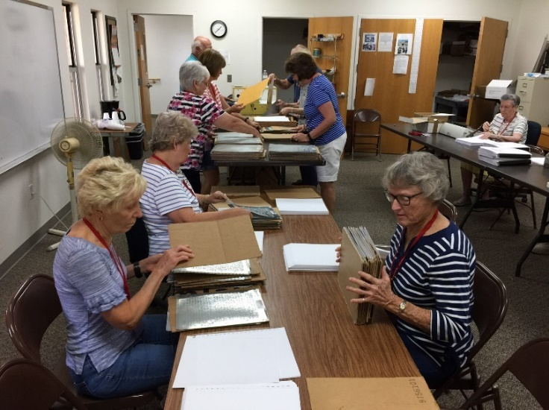

The Faith Lutheran Braille Team was in full production on September 11th, and completed 13 Copies of Proverbs and Song of Songs. A completed book is 90 Pages.

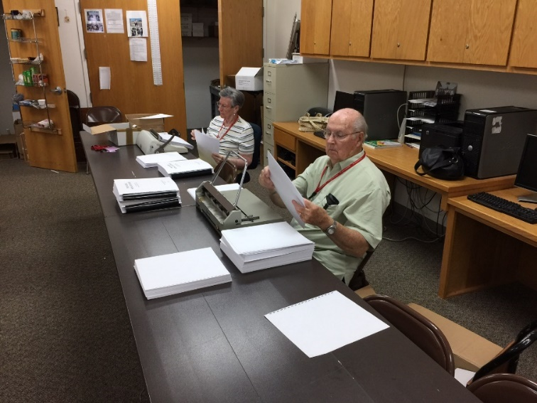

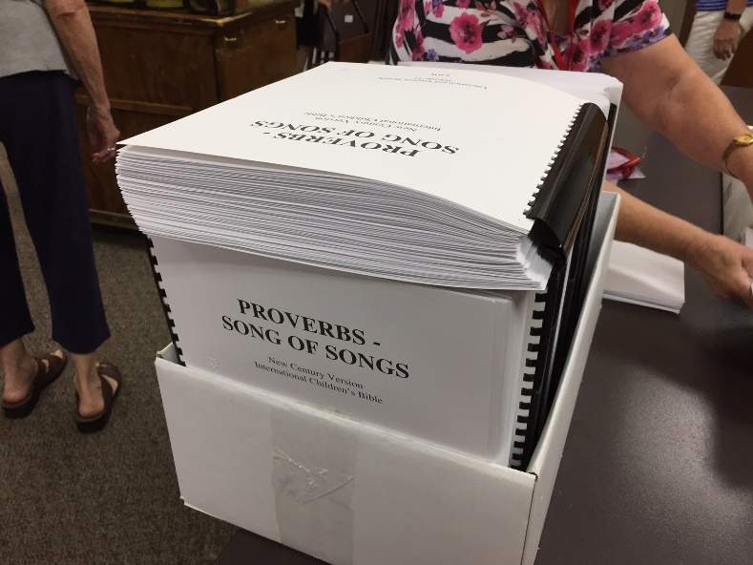Diane Huff, Jeanette Faske and Pat Priem insert special punched embossing paper into the metal plates so the Braille letters can be machine impressed. The filled plates are taken by Carol Hancock and Julie Rauch for quality control and passed to Frank Rauch who puts the plates one at a time through the pressing machine. Wayne Schmidt gives the embossed sheet to Lois Howe who compiles the 90 sheets in order and gives the plates to Jane Schmidt who returns the plates back for refilling   Moni Neeb binds the 90 sheets into a completed Book. Odell Faske punches holes in the special paper so the pages can be bound into books.

A box of completed books ready to be sent  
so the Blind can study God's Word.   
  
If you desire to help in this vital ministry, please call Lois or Paul Howe.

**Lutheran World Relief Quilts**

**Go to**

**Hurricane Harvey Victims**

The ladies of the LWR Quilt Group voted unanimously to send all 68 quilts that we had made since the last shipment in April.

They were packed and send along with other collected items at church. They were packed with Prayers, Love and Blessings.

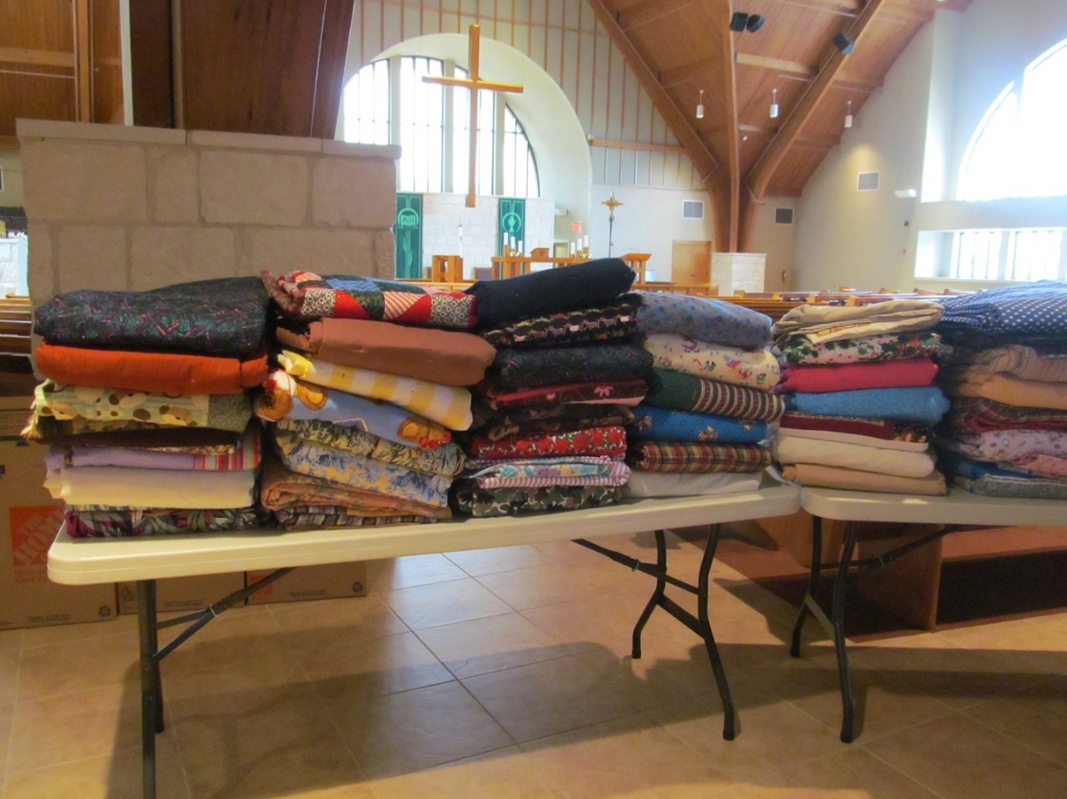**+**

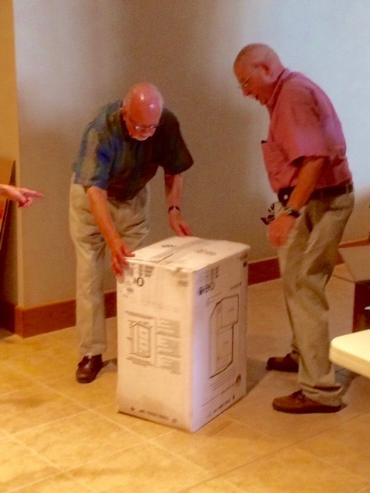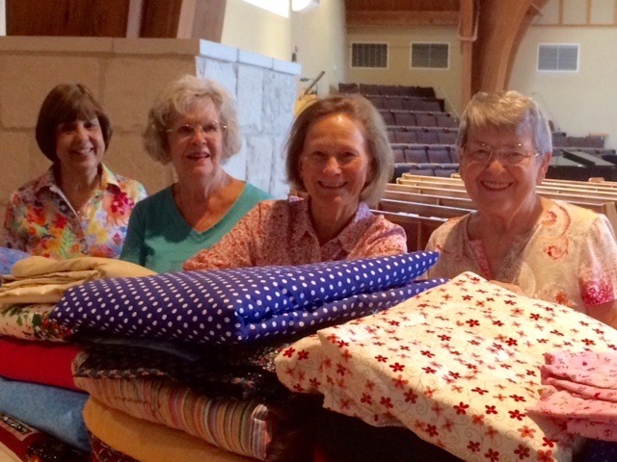

Jeanette Frese, Sherry Richter, Linda Carter, Gert Schriner

(above)

Our “Main Packers” Leland Frese, John Bocek

(right)

Angel tree24c3_print.tiff**New Life Home for Girls:  ANGEL TREE CHRISTMAS LIST**

**For over 20 years, Faith Lutheran Church has sponsored gifts to the troubled and neglected young girls who receive care at the UPBRING’S NEW LIFE HOME for GIRLS.**  **Last Christmas, friends & family of Faith sponsored over 80 Girls with specified gifts, clothes, arts & crafts, personal treasured items and monetary donations, including gift cards! This Christmas season, due to the large occupancy & mass coordination of this event, the New Life administrators have once again requested an EARLY START!!!!!**

**Please prayerfully consider sponsoring a child of God with this special ministry.  Watch the Ministry Center & church bulletin for further details beginning in October. Questions & participation may be directed to members of the Swafford Compass Group or Danny and Mindy Swafford**. **Thank you for your continued ministry!**

**Blessings to you ALL, Danny and Mindy Swafford and the “AND BEYOND” Compass Group**

**STEWARDSHIP 365**

Our stewardship campaign theme this year is “**Living Christ.**” It comes from our congregational mission statement, “Know Christ, **Live Christ**, Make Christ Known.”

I am very excited about this year’s campaign. You see, we had two new people join our board this year. Not only do they have a zeal for stewardship, they are also creative and very inquisitive. Our board meetings are often lively and recently included the following discussion topic: “why is it we only set aside a single month (October) to promote stewardship within the congregation. Aren’t we called to be good stewards year-round? Shouldn’t we, therefore, promote stewardship programs and stewardship opportunities throughout the year?”

Indeed, Faith is a community of believers who share a long tradition of generous giving of treasure and time, **365** days a year. We’ve created a slide presentation, for viewing on the monitor at the Welcome desk, to highlight the many ministries and service opportunities supported by our members. The presentation is frequently updated with current activities, so stop by often!

I encourage you to follow the example of our newest board members and join a church board or volunteer to serve in an area for which you have a passion. You can make a real difference in your church and in your community.

Stewardship envelopes will be placed in your mailbox during the first week of October. The envelope contains two pledge cards. One card is for the **2018 Operating Budget,** the other card is for the **Capital Campaign (Always Sharing God’s Gifts)**. 2018 is the final year of the three-year capital campaign. If you have already made a pledge to the capital campaign there is no need to return this card. If you’re a new member or haven’t made a pledge to the Capital Campaign you may do so using this card. Please prayerfully consider your financial support of this ministry and drop you pledge card(s) in the Pledge Box, located in the narthex, during the month of October.

Tom White

Board of Stewardship

**Elderberries2.tiff**

“*All the days with the oppressed are wretched, but the cheerful of heart has a continual feast*.” Proverbs 15:15 (NIV)

**The SENIOR SOCIAL GROUP**

**ITS WURSTBRATEN TIME** – and the ***Senior Social Group*** is again making it easy for ALL FLC members to enjoy Zion Lutheran’s **November 6** big event.  No need to drive out to Walburg and get in those LONGGG lines.  The SSG will be selling tickets for the Monday Wurstbraten (Roasted Sausage) meal which includes potato salad, Cole slaw, sweet potatoes, green beans, sauerkraut, sliced white bread, and pickle for the same $10.00 price as Zion’s.  We will offer the meals To-Go at the Annex Building or to eat here at **B-116 from 5:00 to 6:30 PM**.  *Ticket sales for the meals will take place in the narthex on* ***Sundays October 22 and 29***.  Checks should be payable to Jerry Stamm.

The SSG will also offer fresh-baked peach cobbler for an additional $1.00 cash each serving at the door.

HELLO ALL SENIORS (50 and up) WHO WOULD ENJOY PLAYING GAMES WITH A GROUP OF FELLOW CHRISTIANS ONE SUNDAY EVENING EACH MONTH. IN OCTOBER THE FAITH OWLS WILL BE GATHERING SUNDAY OCTOBER THE 9TH FOR FUN, CHRISTIAN FELLOWSHIP AND SNACKS.  
The Faith's OWLS (Older Wiser Lutherans) will meet Sunday October the 8th in Room 116 from 6:00 pm to 8:00 pm to enjoy an evening of

Christian fellowship, fun, food and games.

The game will be decided soon.  
Bring a snack to share; coffee and drinks provided.

Invite your OWL friends to join you.  
 If you have any questions please contact the OWL's coordinators

Bill Sheaffer or Jo Ann Sheaffer.

** OCTOBER 19, 2017 **

**Senior Advocacy Group (SAG) Seminar**

**Severe Weather Forecasting &**

**How Seniors Can Prepare**

**Paul Yura, Severe Weather Warning Meteorologist**

**National Weather Service (NWS)**

Preparing for severe weather can be a challenge at any age, and getting the most current advice on dealing with severe weather can be critical to our survival. The NWS is the prime source for the public and the media to access this advice.

On October 19, Paul Yura, NWS, will speak on Severe Weather Forecasting & How Seniors Can Prepare, and his presentation will be educational, entertaining, and also contain some outstanding color graphics and video. You likely recently saw Paul being interviewed on numerous TV stations regarding Hurricane Harvey.

Our October 19 seminar will be held in Room B116, and we will have light refreshments and social time starting at 9:30 AM with Mr. Yura speaking at 10 AM. We are again inviting our friends at Zion, as well as other local churches, and we anticipate a large crowd for this excellent opportunity to hear Mr. Yura speak on this important and timely topic.

Our November 16 SAG Seminar will feature Dr. Carl Trovall, Dean-College of Arts and Sciences, Concordia University Texas, speaking on A Theological Perspective on End-Of-Life Issues. This will again be a unique opportunity to get a scriptural perspective on issues faced by each of us.

TESS’ TIDBITS

“Enchanted”

New Mexico, Land of Enchantment! Valle Escondido! Hidden Valley! On the Enchanted Circle that runs from Taos past Valle Escondido, through Angel Fire, Eagles Nest, Red River, Questa and back to Taos. For me, this visit is an enchanted time in this enchanted place. Bob and Judy's mountain cabin at 8,400 feet is the perfect setting for the long celebration of my 85th birthday. Fluffy white clouds in brilliant blue skies, cool temperatures, abundant wild flowers and good times with family and friends. Delicious food! And golf! It's easy to forget that all is not well with everyone everywhere. But I am ever mindful that I am at an enchanted point in my life. Between years of caregiving and the grief that followed Frank's death and problems that may accompany my final years in this life.

Judy met me at the Santa Fe airport. LaChoza, where the locals go, had a 45-minute wait for a table. But there were two empty places at the end of the counter in the crowded bar. Judy looked at me quizzically? Fine with me! I hopped(?) up on a stool and we enjoyed a delicious dinner. The hour and a half drive to the cabin was good mother-daughter time. And it has just gotten better!

The sun comes up over mountains just across the golf course. Morning truly 'guilds the skies'. The sliding door in my bedroom opens to a little balcony overlooking a hillside covered with pine and aspen trees. Leaves are just beginning to turn. My ankles are cold in the morning air. In the upstairs bathroom, I look up at big beams and rafters coming to the perfect peak, designed by my brother and his slide rule. Perfect for the cross shape of the roof. The wood is beautiful! The construction amazing! I remember the summers we worked on the cabin. Beginning in 2006. From before it was a hole in the ground. Such a wonderful family time! Hard work! Frank's health was beginning to fail, and the elevation was difficult for him, but he could help some. And with Paco in his lap, he was a happy observer of the work in progress. Evenings were spent around the huge fireplace in our rental cabin. On the deck, hummingbirds sat on our fingers at the many feeders. And, time, daylight, and energy permitting, we took opportunity to see how many golf balls we could accidentally put in gopher holes. Those were the days! Enchanted days!

It's eleven years later. The cabin is finished and well used by Bob and Judy, their family and friends. Frank is no longer with us, but we often feel his presence. That was especially true yesterday as we took a little heart-shaped container of his ashes up a rough Jeep road to a nearby mountain-top. There, at some 11,000 feet, looking off toward the highest peaks in the Sangre de Cristos, Bob and Judy, Ed and Kathy DeLucas, Bill Elkjer and I remembered Frank. Judy scattered his ashes to the wind. As they floated above the wild flowers, we choked back tears. We celebrated the husband, father and friend he was to us. I missed having Mike and Peggy and my grandchildren.with me. Years ago, Frank and I had asked Mike to scatter our ashes over Juniper Point in Washington's Okanogan country. Above the tall fir tree where, on one hunting trip, he had carved our initials. That thought was dear to Frank. That, too, would have been an enchanted moment. But I would not have been there to witness it.

And now, in this enchanted time, between the pages, I celebrate the gift of health and days. Thanks be to God, from whom all blessings flow.

Tess Todd