**THE GRAPEVINE**

**Faith Lutheran Church**

**November 2017**

**4010 Williams Drive**

**512-863-7332 Georgetown, Texas 78628**

**Website: flcms.org**

**FOR ALL GENERATIONS**

*Jesus Christ is the same yesterday and today and forever.*

(Hebrews 13:8, NIV)

I spent part of the last Wednesday in October working with a group of Concordia High School sophomores and juniors, along with one of their science and math teachers. We were laboring in Faith’s “back 40,” clearing rocks so that lawn mowers may pass easily over more of the acreage and people may walk across it with less fear of tripping. Even though the weather was perfect for working outdoors and that spirits remained high, I suspect that there were a few sore backs the following morning. There really isn’t much fun in bending over and picking up rocks, neither for teenage boys nor for nearly 60-year-old pastors. So, as I hauled wagons full of rocks and buckets full of dirt, I engaged in conversations and I prayed. I thanked God for healthy muscles and willing hearts. I blessed him for sunshine and cool breezes. And I begged Him, begged Him, to keep these young men Christian throughout their lives.

It is an article of faith among us that God preserves His Church, that in every generation through the power of His Spirit working through the ministry of His holy Word, despite persecution, temptation, and ridicule, God keeps a remnant faithful to His Son. That is profoundly hopeful. God’s pledge to keep His Church alive and vibrant until the end of time, and even into eternity, is incredibly comforting and encouraging. But in the smallness of my mind and heart, that promise can sometimes seem a little generic, especially when what I want is that these particular sophomores and juniors be part of Christ’s faithful remnant throughout their generation in time and beyond all generations forever. More than knowing math and science, I want the boys I worked with on that Wednesday to know Jesus; more than going to Concordia High School, I want them to go to heaven; more than being Texan or American, I want them to be Christian.

Blessedly, so does God! The Savior of All Nations wasn’t speaking generically when He declared that He wants all to be saved; He was speaking very specifically about every particular person, none excepted (not sinner-by-birth Walt Pohland, not sinner-by-birth Kim Jong Un, not sinner-by-birth anyone!) but each individually known by name and loved with an everlasting love. It was certainly for all that Jesus shed His blood from the cross in the fullest expression of God’s love, but it was just as certainly for each (again, none excepted.)

That each and all may know the salvation from sin and death that is in Christ alone, God in His unfathomable goodness ordained the ministry of the Church for the proclamation of the gospel and the administration of the sacraments. It is through the Holy Spirit’s use of these means that the Church is preserved through all generations. What blessing, privilege, and commission, then, is ours! As believers in Jesus, the Spirit of God uses us to speak specific words to specific people at specific moments in specific circumstances—even if those may be disguised as such seeming random occurrences as picking up rocks and shoveling soil alongside some hairy-legged high school boys participating in an off-campus service event, who become through the course of a morning subjects of heartfelt prayer.

So, Lord Jesus, for each and all, I beg You—keep them Christian! Amen.

Prayerfully,

Pastor Walt Pohland

**Received with Thanksgiving**

All through the month of October, I’ve been pondering this particular sign that is on one of the preschool classroom doors, “I’m Trying to Love Spiders. (It isn’t easy.)”[1] At first, I just dismissed the whole notion. After all, I don’t mind spiders. I wouldn’t say I “love spiders,” per se, but they serve a useful purpose in God’s creation. They do, after all, help keep the mosquito population under control, and that is very good. But, what about scorpions? They are technically distant cousins of spiders. Does that mean that I should take this motto seriously and try and “love scorpions” too???

I can give you a whole list of reasons why I don’t think this is a good idea. Scorpions are, after all, creatures with a stinger AND claws that are able to work themselves into all kinds of places where they should not go. It would be one thing if they stayed outside under the rocks in the prickly pears and only came out to use their “tools” to prune the garden and protect the flowers. But no, these creatures are a discontented lot. They are intent on forcing their way through the smallest crevices and bulwarks the world has to offer! Can anyone truly “love” these creatures???

At this point I am confronted with the biblical truth that Paul once reminded his young pupil Timothy of, “For everything created by God is good, and nothing is to be rejected if it is received with thanksgiving, for it is made holy by the word of God and prayer.” Paul, at this point is actually talking about the future when many people will “depart from the faith by devoting themselves to deceitful spirits and teachings of demons, through the insincerity of liars,” who were repurposing God’s good Creation (food in this case) in order to lead people away from Christ. Instead of seeing God’s purpose, and being thankful for His provisions via His good creation, they were twisting creation to their purpose. Needless to say, God’s purpose for His creation is quite different. In His creation, “everything created by God is good,” period.

With that in mind, it makes me stop and think that I should pause this Thanksgiving season and reconsider my position on this puzzling creature, the scorpion. I’m not suggesting that I’m going to be, “trying to love scorpions,” but I am at least willing to consider, “trying to be ‘thankful’ for scorpions.” And the more I think about it, are we too terribly different from scorpions ourselves? At the time of creation, God created us male and female. And as He took in everything He had just made, He said, “it was very good.” But shortly after that, Adam and Eve rebelled and sinned against God by breaking the very boundaries that He had put in place for their own protection. And shortly after that, Cain took up arms against Abel; brother against brother; sister against sister. No one was immune. There were none who were righteous, no, not one (Rom. 3:10; Ps. 14:1-3).

When we stop and think about it that way, the scorpion really doesn’t look that bad. While I may not understand why God created them, through the eyes of faith, I can most definitely see how thankful I am that He loves His creation.- especially those whom He made in His image. So much so, He sent His own Son, Jesus, to save us broken, stinging, backbiting men and women from the punishment that we deserve. For that, yes for that, I am truly thankful. Amen.

Happy Thanksgiving,

Pastor Bill.

[1] This is actually from a children’s book with the same title, written by Bethany Barton

**Helping Hands Lutheran Women’s Missionary League**

Our mission for this month is Hope Alliance which was formerly called Williamson County Women’s Shelter.

The greeting card orders can be picked up on Sundays October 22nd and 29th before and after each Church service. Thank you to everyone who placed an order.

Our Bible Study for our November 14th meeting will be Jesus Christ Above All found on page 22 of The Lutheran Woman’s Quarterly for Fall 2017. The Women’s Advent Devotion and Luncheon will be on December 3rd.

We will once again be baking and selling our homemade cookies. We will have gluten free, sugar free and regular cookies as well as cookies with nuts and no nuts. This year we will be asking for a free will offering for each box of cookies.

We always welcome all ladies of the Church

JOY MISSION CIRCLE

Yummmm…Do you smell that? Is it cookies? No…bread! No…pie! No… It is ALL of those things!

Yes…the Joy Mission Circle Bake Sale is coming!!! Mark your calendars for November 19th and come see what goodies we will have for you.

Also mark your calendars for our next meeting Tuesday November 7th at 6:30 pm in Room B116. We will have a short business meeting before our Bible Study.

Oh…and another date for your calendar! Dec. 3rd will be the LWML Advent event hosted by Joy Mission Circle and Helping Hands. It will be a luncheon affair; we would love to have all the ladies at Faith attend!

Questions? Feel free to contact Joanna Roche.

MC900064971[1]**COOKIES FOR MISSIONS**

**Who Likes Homemade Cookies?? Y’all do!**

Helping Hands will again sponsor **“Cookies For Missions”** to help fund the Mission Gifts

selected for 2017 . Our Mission Gifts total an average of $2000 annually.

The Homemade cookies will be sold for a free-will offering.

You may choose between: Assorted, No Nuts, or Gluten Free.

In 1 dozen or 2 dozen boxes**.**

**Cookies will be sold December 3rd only**

You may pay by *Cash or Check* for your Cookies Please make checks payable to ***Helping Hands***, with ***“Cookies”*** in the memo line of your check.

That is the theme of this year’s Advent Women’s Luncheon. Having the goal of beginning Advent with a Jesus-centered spirit, Helping Hands and Joy Mission Circle invite you, your friends, and your relatives to a salad luncheon and special program on

**“The Best Surprise is**

**NO SURPRISE!”**

**Sunday, December 3, from 12:15-2:00 p.m., in Room B116.**



Helping Hands and Joy members will provide the meal, although you are welcome to bring a salad if you wish. You will receive an invitation in your Faith mailbox in early November. Your RSVP will help us know how many will attend.

Please plan to come – it’s a great fellowship experience. If you have questions, call Jeanette Frese or Joyce Best.



OUR PRESCHOOL AT FAITH

**Meet another one of our new teachers at**

**Faith Lutheran Preschool**

***Janet Templeman is our new Three Year-Old Teacher, and on staff with our after school program.***

Ms. Janet writes:

“This will be my first year of teaching at Faith Lutheran Preschool. I have many years of experience in the early childhood education field.

A little about me... I was born in Springfield Illinois. My family and I have lived in Georgetown for six years. I am married to Chris and we have two boys, Codie and Carson. I love going to church here at Faith Lutheran Church. I also enjoy spending time with my family.

Each child in my class is special to me! We have an exciting year ahead of us!”

Spotlight on Compass Group Ministry

*For the next several months, this spot in our church newsletter will be highlighting various Compass Groups at Faith Lutheran. Each Compass Group Leader has been asked to write a summary about their group to share with the congregation. November’s spotlight falls on the Schmid Compass Group.*

***Nothing is happenstance in the Christian Walk***

The Schmid Compass Group has been meeting on the first Wednesday of the month for nearly eight years. During their time together, they have studied a variety of Christian topics such as Christian Living, Discipleship, Prayer, and Worship. Currently, they are using Max Lucado’s book “The Touch of the Masters Hand” to learn more about becoming more like Jesus.

Members of this group say being in Compass Ministry helps them grow in their learning, practice, and experiences of loving God, their church family as well as show them how to love their neighbors as themselves.

While they are close-knit, the group has changed over time as people move or leave and new people join. They have grown again recently, adding two more couples--new members as well as established members. It is a dynamic

group, changing as the Holy Spirit moves. Through the years, they have shared with one another their joys and sorrows and felt Christian unity by bringing it all to the Lord in prayer. It is a joy for them to see Jesus always at work in their lives, and to realize nothing is happenstance in the Christian walk.

On behalf of the group, Susan Schmid says “It's been an honor, privilege, and joy to share the love of our Lord Jesus Christ with other church family, neighbors and guests. We pray for the Holy Spirit's guidance and will since it is ultimately His ministry.”

Compass Ministry deeply enriches their lives, and they encourage members of our Congregation who are not in a Compass Group to find out more about becoming involved in this ministry. They are thankful for this ministry and its support and leadership by Faith’s Staff. To God be the glory!

*If you would like more information about our Compass Group Ministry, please contact Peggy Hill, Compass Groups Coordinator:*

**New Life Home for Girls:  ANGEL TREE CHRISTMAS LIST**

**For over 20 years, Faith Lutheran Church has sponsored gifts to the troubled and neglected young girls who receive care at the UPBRING’S NEW LIFE HOME for GIRLS.**  **Last Christmas, friends & family of Faith sponsored over 80 Girls with specified gifts, clothes, arts & crafts, personal treasured items and monetary donations, including gift cards! This Christmas season, due to the large occupancy & mass coordination of this event, the New Life administrators have once again requested an EARLY START!!!!!**

**Please prayerfully consider sponsoring a child of God with this special outreach ministry – a way of sharing some Christian love with these abused and troubled teenage girls. Specific request sheets from the girls are available at the Ministry Center beginning Sunday, November, 5th. You may choose one of these, make a monetary donation, or purchase a gift card for them. Questions & participation may be directed to members of the Swafford Compass Group or Danny and Mindy Swafford .**

**Thank you for your continued ministry!**

**Please note: All Christmas gifts, clothing and contributions are due by Thanksgiving Weekend.**

**Blessings to you ALL, Danny and Mindy Swafford and the “AND BEYOND” Compass Group**

LWML Capitol Zone Retreat

February 23-24, 2018

Camp Lone Star

Ladies, please mark your calendars for the LWML Capitol Zone Retreat in February! It will be a time of rest and renewal. Our guest speaker/musician is Wendysue Fluegge from Wisconsin where she serves her church as worship leader. She is a songwriter and a teacher. Wendysue will help us explore intentional mission in the midst of the everyday flight of life through her “Divine Destinations” program. She led the worship music at the LWML National Convention and will be leading the music at the LWML Texas District Convention in Waco in July 2018. You will not want to miss this opportunity. For registration or questions please contact Patricia Willoughby.

Come make new friends! There will be a salad supper on Friday night and a silent auction. We look forward to having join us.



*“Let all that I am praise the Lord, may I never forget the good things He does for me.”*

Psalm 103:2 NIV



**November 16, 2017**

**Senior Advocacy Group (SAG) Seminar**

**A THEOLOGICAL PERSPECTIVE ON**

**END-OF-LIFE ISSUES**

**REV. DR. CARL TROVALL, DEAN-COLLEGE OF ARTS AND SCIENCES,**

**CONCORDIA UNIVERSITY TEXAS**

Whether for ourselves or a loved one, we are very likely to face difficult issues involving hospice care, Do Not Resuscitate directives, etc. as we age. How helpful it is to know what guidance Holy Scripture provides us in making these decisions!

On November 16, Dr. Carl Trovall will again delve into the theological perspectives on end-of-life issues. You will hear what the Bible says regarding these issues, and you will also hear of the great comfort the Bible provides to allay feelings of concern, guilt, etc. in the decision making process.

Our November 16 seminar will be held in Room B116, and we will have light refreshments and social time starting at 9:30 AM with Dr. Trovall speaking at 10 AM. We are again inviting our friends at Zion, as well as other local churches, and we anticipate a large crowd to hear Dr. Trovall speak on this important topic.

We will not have a December SAG Seminar given the many activities surrounding the Advent and Christmas season. Watch for the details on a much requested SAG Seminar on January 18, 2018, in the next *Grapevine*!

**The Texas District Church Extension Fund**

**CEF is a Unique Ministry**

The church extension ministry provides Texas District Lutherans a unique opportunity to make funds available in support of the Great Commission: "Go ye, therefore, and make disciples of all nations."

**Yesterday**

The Church Extension Fund was established by a District Convention resolution in 1888 to provide loans to congregations. The Texas District Church Extension Fund is a ministry of the Texas District. Since 1888, CEF has provided consultation and low cost funding for Texas congregations to build and expand.

**Today**

More than 11,000 investors make the Texas District Church Extension Fund possible. With more than $160 million in assets today, CEF is presently assisting more than 130 congregations throughout Texas with loans to help expand the Kingdom.

**Tomorrow**

CEF’s goal is to anticipate and be responsive to the ministry needs of the future; to continue to provide quality services, resources, training and leadership, and vision to meet those needs. We will continue to assist congregations to reach the lost, disciple the saved and care for people-locally and globally as we identify new and creative ministry opportunities throughout Texas.

**To learn more about investing in CEF and make ministry happen; go to www.texascef.org, or call**

**1-888-951-1233, or call Calvin Spencer at 512-868-8214.**

The current CEF investment rates are:

Flex Savings 0.500%

Fixed-rate notes - 1 Year 1.500%

Fixed-rate notes - 3 Year 2.000%

Fixed-rate notes - 5 Year 2.500%

Floating-rate notes - 1 Year 1.250%

Floating-rate notes - 3 Year 1.625%

Floating-rate notes - 5 Year 1.875**%**

***CHRISTMAS LUNCHEON FOR SENIOR SOCIAL GROUP***  -  in B-116 on Monday, December 4 at 11:30 AM.  Catered meal will include salad, Chicken Kiev (breast stuffed with ham and spinach), roasted new potatoes, mixed steamed veggies, pineapple casserole, rolls, red velvet cake, coffee, tea, and water.  Cost is only $10 with tickets on sale in the Ministry Center on Sundays November 19 and 26

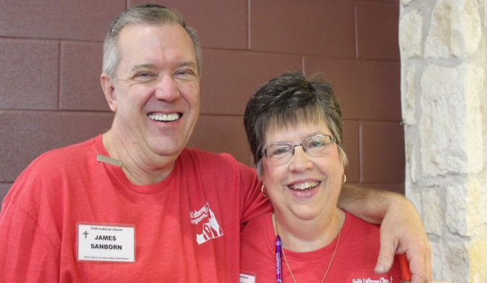

**The Board of Parish Fellowship** would like to say:

*THANK YOU!*

To all the amazing people that volunteered to help at the Picnic. From set up at 7 am, to working in the kitchen, manning food and drink tables, assisting outside with the children's activities, participating in the Youth Dessert Auction and staying to help afterward with the clean-up at the Community

Center. You worked so hard to make the event a

success!

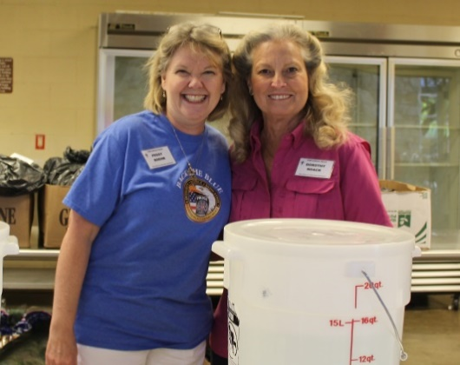 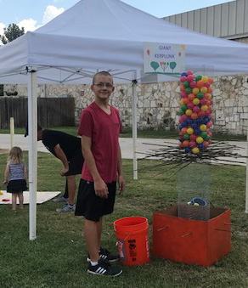 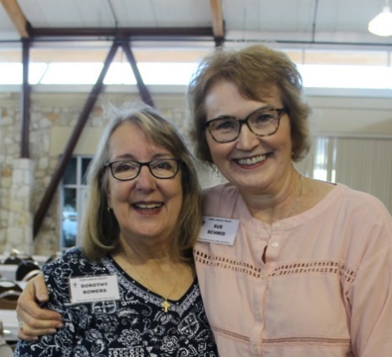

A **HUGE** shout out to everyone for bringing fantastic side dishes and delicious desserts to share with everyone!!

***MANY*** thanks to Community Coffee and Rentsch Brewery for supplying us with great drinks to wash down the bounty of tasty food!!

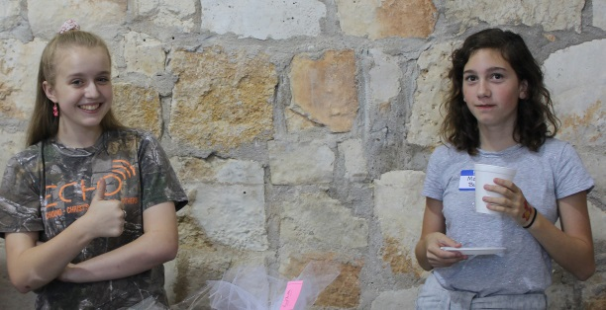

***The Youth raised over $2100.00 at the Dessert Auction!***

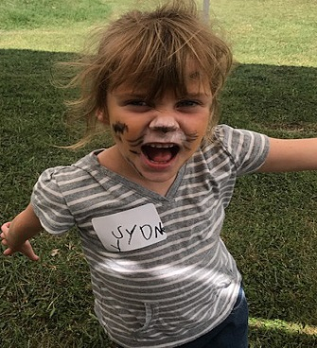 

**Save the Date for the next church Picnic: Sunday, September 30, 2018**



**CHRISTMAS IS COMING** and so is Faith’s annual Christmas Cantata!!  Practices began on Thursday, September 21st at 7:00 P.M. in the Choir Room. All members who enjoy using their God-given singing ability, in His service and to His glory, are invited to join us. As in past years, there are no auditions. The Cantata will be sung twice at Faith: On December 17th at 8:30 A.M. worship and on December 31, 2017 at 11:00 A.M. worship. If you have questions, please call Phyllis Draheim at 512-863-7332.

Tess Todd’s Tidbits

Feeling guilty about Thanksgiving!

One of the first things I learned after becoming Lutheran was that Lutherans are supposed to feel

guilty! I practice it regularly. Maybe that saying stems back to when the young Martin Luther went to confession so often, and stayed so long, thinking of everything little thing he had done, or not done, that his confessor grew tired of listening to poor guilt-ridden Martin and told him, in effect, “Get out of here and quit bothering me with such trivia”. In the wee small hours of the morning, when sleep won’t come, and all the monotonous little mind games I play won’t calm my mind, I go down the winding guilt road. This trip stumbles over my careless and rude words, selfish actions, resolutions not kept, good deeds not done. Failures of character, all! Sins, surely!

I rejoice in the good health with which I am blessed. In fact I boast about it! After all, should I not be thankful that, in my eighty-fifth year, I can traipse off the Africa, climb in a safari wagon, or walk with a guide, for a game drive? But is that boasting appropriate when some of my listeners, perhaps not even near my age, use walkers, or canes, or cannot walk at all? Makes me feel guilty for being thankful. As though, through some merit of my own, I am chosen to be healthy while others, no less deserving, are not. Perhaps I should be thankful and be quiet.

I like my new apartment and lifestyle here at Wesleyan Independent Living. I makes growing old and living alone comfortable and enjoyable. I am thankful that I am in the position to plan on spending my remaining years here. But when I look at all the space I have and my beautiful new furniture and think about the activities and programs available to me, not to mention the good food in the dining room, I feel guilty. Guilty that I live in such ease and comfort while many, even more deserving than I, do not.

Frank and I were blessed with sixty-three years of marriage. Years that saw us prosper beyond our fondest dreams, travel to far-away places, and raise two healthy, well-adjusted children. We were thankful for these blessings. We shared care-giving responsibilities during our parents’ final years. It seemed we had it easier than many. We were thankful. Even Frank’s final years were not as difficult as is often the case. Despite his diagnosis of Dementia with Lewy Bodies, Frank lived at home and died at home. I was thankful for that. Thankful for my good health and strong back! And for the enormous loving support we received from family, friends, neighbors, pastors and fellow members of our church. Now, when I talk with others in similar circumstances, I try to listen. Oftentimes the spouse is not strong and healthy and doesn’t have the support system I had. I feel guilty for being thankful that it was

easier for me.

My children and grandchildren invite me to visit them. They make me welcome and plan special trips and activities to make sure that I have a wonderful time. I treasure these close family ties. I am thankful for them. I boast of them to anyone who will listen. But I need to be sensitive to those who are estranged from family. Or to those who deal with developmental, dependency, health or emotional problems. For me to boast of how thankful I am for my children’s success is rubbing salt in the wound of my listener.

They say confession is good for the soul. I’ve confessed feeling guilty for being so thankful. Thanks be to God, I know He forgives me! But I keep thinking of the man in the Bible who thanked God that he wasn’t as “that man”. And Jesus didn’t like that! Makes me feel guilty!

Wishing you a blessed Thanksgiving!

Praise God from Whom all blessings Flow. Tess Todd