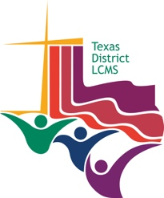
HOPE FOR UNCERTAIN TIMES
Faith Lutheran Church, Georgetown, Texas
Rev. Michael W. Newman

Breakout Discussion 1: Faith versus fear

Read Psalm 46:1-3

- How does our world today resemble what the writer describes in verses 2 and 3?

- How does verse 1 of the Psalm acknowledge the broken condition of the world AND lift up a reason for hope?

- How does faith in God, the Savior, fight fear in your life?

Breakout Discussion 2: Grace versus works

Read Ephesians 2:8-10

- How would you define God’s GRACE?

- What do these verses say about our own abilities to face challenging and hope-draining times?

- How does the blessing of God’s grace in Jesus provide hope for you and this world during the crisis we face?

Breakout Discussion 3: Scripture versus conjecture

Read Colossians 3:12-17

How do these verses from God’s Word contrast to the narrative and actions of the world?

How have you let “the word of Christ dwell in you richly” in your life?

How is the Holy Spirit directing you to use God’s Word and to reach out to with God’s Word to others?

