Eighteenth Sunday after Pentecost
October 1, 2023

Faith Lutheran Church Georgetown, TX 78628
512-863-7332 flcms.org
(The Lutheran Church—Missouri Synod)

WELCOME

TEMPLE TALK: Lutheran Women’s Missionary League – Susan Schmidt

INVOCATION:
Pastor: In the name of the Father and of the Son and of the Holy Spirit.
People: Amen.

CALL TO WORSHIP: Psalm 25
Pastor: To You, O Lord, I lift up my soul. O my God, in You I trust;
People: let me not be put to shame; let not my enemies exult over me.
Pastor: Make me to know Your ways, O Lord; teach me Your paths.
People: Lead me in Your truth and teach me, for You are the God of my salvation; for You I wait all the day long.
Pastor: Remember Your mercy, O Lord, and Your steadfast love, for they have been from of old.
People: Good and upright is the Lord; therefore He instructs sinners in the way.
Pastor: He leads the humble in what is right, and teaches the humble His way.
People: All the paths of the Lord are steadfast love and faithfulness, for those who keep His covenant and His testimonies.
Pastor: Glory be to the Father and to the Son and to the Holy Spirit;
People: as it was in the beginning, is now, and will be forever. Amen.

OPENING HYMN: “Christ is Made the Sure Foundation” (Lutheran Service Book, #909)

Christ is made the sure foundation,
Christ, our head and cornerstone,
Chosen of the Lord and precious,
Binding all the Church in one;
Holy Zion’s help forever
And our confidence alone.

To this temple, where we call You,
Come, O Lord of hosts, and stay;
Come with all Your loving-kindness,
Hear Your people as they pray;
And Your fullest benediction
Shed within these walls today.

Grant, we pray, to all Your faithful
All the gifts they ask to gain;
What they gain from You, forever
With the blessèd to retain;
And hereafter in Your glory
Evermore with You to reign.

Praise and honor to the Father,
Praise and honor to the Son,
Praise and honor to the Spirit,
Ever three and ever one:
One in might and one in glory
While unending ages run!
Text: Public domain

CONFESSION AND ABSOLUTION:
Pastor: Beloved, our help is in the name of the Lord,
People: who made heaven and earth.
Pastor: If You, O Lord, kept a record of sins, O Lord, who could stand?
People: But with You there is forgiveness; therefore You are feared.
Pastor: Since we are gathered to hear God’s Word, call upon Him in prayer and praise, and receive the body and blood of our Lord Jesus Christ in the fellowship of this altar, let us first consider our unworthiness and confess before God and one another that we have sinned in thought, word, and deed, and that we cannot free ourselves from our sinful condition. Together as His people let us take refuge in the infinite mercy of God, our heavenly Father, seeking His grace for the sake of Christ, and saying: God, be merciful to me, a sinner.
People: Almighty God, have mercy upon us, forgive us our sins, and lead us to everlasting life. Amen.
Pastor: Almighty God in His mercy has given His Son to die for you and for His sake forgives you all your sins. As a called and ordained servant of Christ, and by His authority, I therefore forgive you all your sins in the name of the Father and of the Son and of the Holy Spirit.
People: Amen.

HYMN OF PRAISE: “Gloria in Excelsis” (Lutheran Service Book, p. 204)
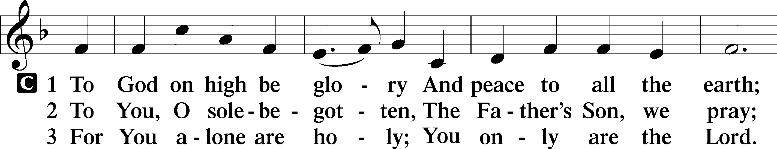
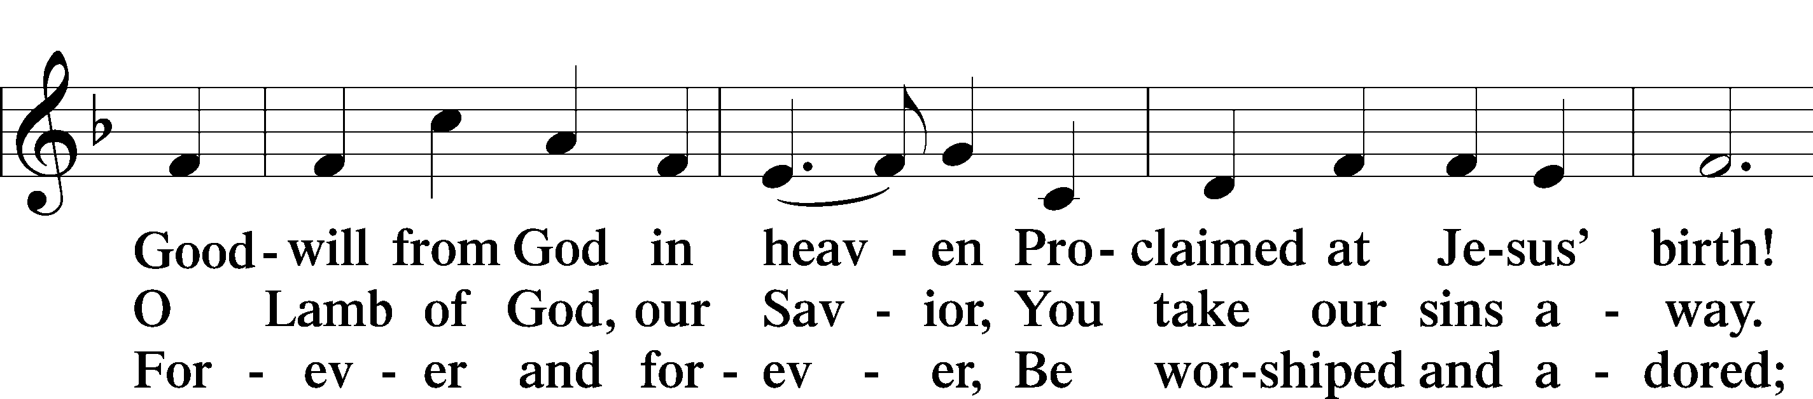
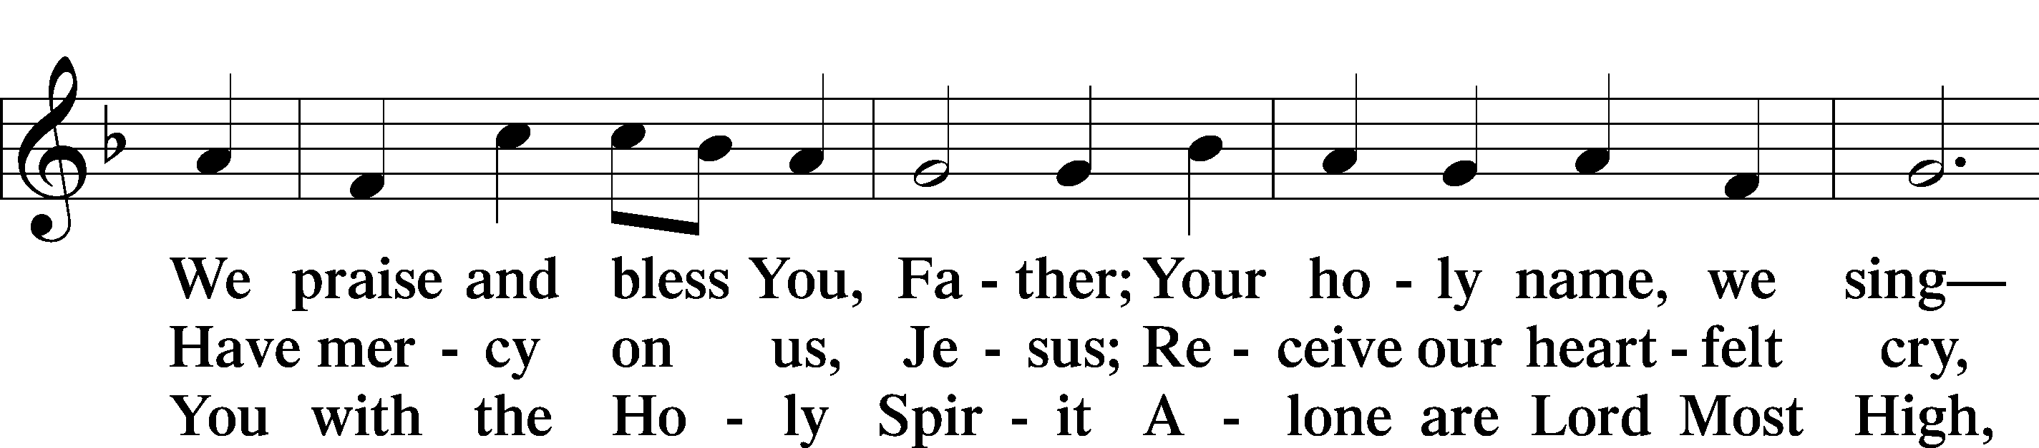
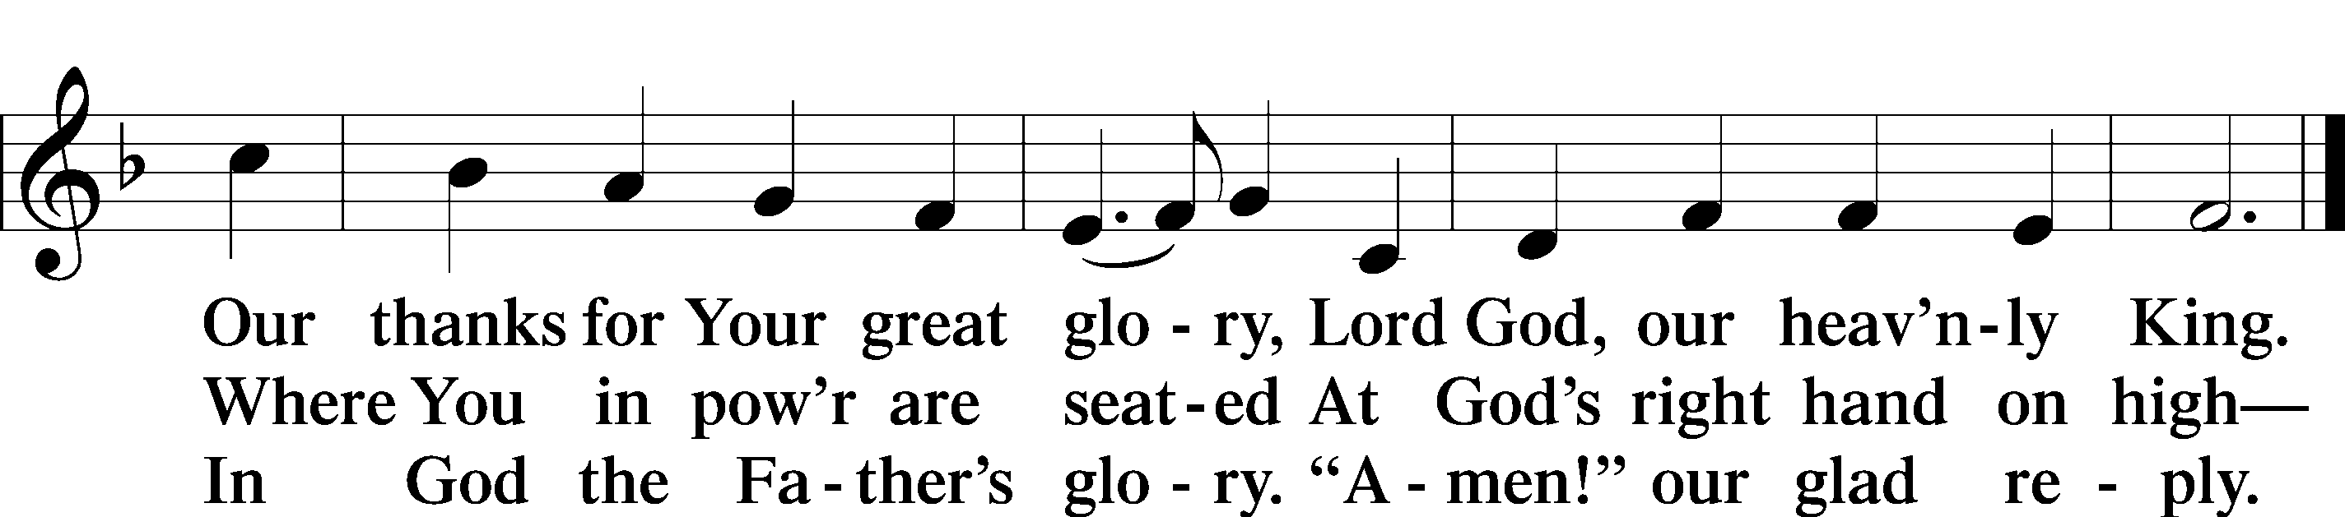

PRAYER OF THE DAY:
Pastor: The Lord be with you.
People: And also with you.
Pastor: Let us pray.
People: Almighty God, You exalted Your Son to the place of all honor and authority. Enlighten our minds by Your Holy Spirit that, confessing Jesus as Lord, we may be led into all truth; through the same Jesus Christ, our Lord, Who lives and reigns with You and the Holy Spirit, one God, now and forever. Amen.

THE OLD TESTAMENT READING: Ezekiel 18:1–4, 25–32
The word of the LORD came to me: “What do you mean by repeating this proverb concerning the land of Israel, ‘The fathers have eaten sour grapes, and the children’s teeth are set on edge’? As I live, declares the Lord God, this proverb shall no more be used by you in Israel. Behold, all souls are Mine; the soul of the father as well as the soul of the son is Mine: the soul who sins shall die. . . .
“Yet you say, ‘The way of the LORD is not just.’ Hear now, O house of Israel: Is My way not just? Is it not your ways that are not just? When a righteous person turns away from his righteousness and does injustice, he shall die for it; for the injustice that he has done he shall die. Again, when a wicked person turns away from the wickedness he has committed and does what is just and right, he shall save his life. Because he considered and turned away from all the transgressions that he had committed, he shall surely live; he shall not die. Yet the house of Israel says, ‘The way of the Lord is not just.’ O house of Israel, are My ways not just? Is it not your ways that are not just?
“Therefore I will judge you, O house of Israel, every one according to his ways, declares the Lord GOD. Repent and turn from all your transgressions, lest iniquity be your ruin. Cast away from you all the transgressions that you have committed, and make yourselves a new heart and a new spirit! Why will you die, O house of Israel? For I have no pleasure in the death of anyone, declares the LORD GOD; so turn, and live.”
Lector: This is the word of the Lord.
People: Thanks be to God.

EPISTLE READING: Philippians 2:1–18
If there is any encouragement in Christ, any comfort from love, any participation in the Spirit, any affection and sympathy, complete my joy by being of the same mind, having the same love, being in full accord and of one mind. Do nothing from rivalry or conceit, but in humility count others more significant than yourselves. Let each of you look not only to his own interests, but also to the interests of others. Have this mind among yourselves, which is yours in Christ Jesus, Who, though He was in the form of God, did not count equality with God a thing to be grasped, but made Himself nothing, taking the form of a servant, being born in the likeness of men. And being found in human form, He humbled Himself by becoming obedient to the point of death, even death on a cross. Therefore God has highly exalted Him and bestowed on Him the name that is above every name, so that at the name of Jesus every knee should bow, in heaven and on earth and under the earth, and every tongue confess that Jesus Christ is Lord, to the glory of God the Father.
Therefore, my beloved, as you have always obeyed, so now, not only as in my presence but much more in my absence, work out your own salvation with fear and trembling, for it is God Who works in you, both to will and to work for His good pleasure.
Do all things without grumbling or questioning, that you may be blameless and innocent, children of God without blemish in the midst of a crooked and twisted generation, among whom you shine as lights in the world, holding fast to the word of life, so that in the day of Christ I may be proud that I did not run in vain or labor in vain. Even if I am to be poured out as a drink offering upon the sacrificial offering of your faith, I am glad and rejoice with you all. Likewise you also should be glad and rejoice with me.
Lector: This is the word of the Lord.
People: Thanks be to God.

Lector: Please rise, as you are able.
Lector: The Holy Gospel according to St. Matthew, the 21st chapter:
People: Glory to You, O Lord!

GOSPEL READING: Matthew 21:23–32
When [Jesus] entered the temple, the chief priests and the elders of the people came up to Him as He was teaching, and said, “By what authority are You doing these things, and who gave You this authority?” Jesus answered them, “I also will ask you one question, and if you tell me the answer, then I also will tell you by what authority I do these things. The baptism of John, from where did it come? From heaven or from man?” And they discussed it among themselves, saying, “If we say, ‘From heaven,’ He will say to us, ‘Why then did you not believe him?’ But if we say, ‘From man,’ we are afraid of the crowd, for they all hold that John was a prophet.” So they answered Jesus, “We do not know.” And He said to them, “Neither will I tell you by what authority I do these things.
“What do you think? A man had two sons. And he went to the first and said, ‘Son, go and work in the vineyard today.’ And he answered, ‘I will not,’ but afterward he changed his mind and went. And he went to the other son and said the same. And he answered, ‘I go, sir,’ but did not go. Which of the two did the will of his father?” They said, “The first.” Jesus said to them, “Truly, I say to you, the tax collectors and the prostitutes go into the kingdom of God before you. For John came to you in the way of righteousness, and you did not believe him, but the tax collectors and the prostitutes believed him. And even when you saw it, you did not afterward change your minds and believe him.”
Lector: This is the Gospel of our Lord.
People: Praise to You, O Christ!

Lector: We confess together our Christian faith, using the Nicene Creed.

CONFESSION OF FAITH: The Nicene Creed
I believe in one God, the Father Almighty, Maker of heaven and earth and of all things visible and invisible.

And in one Lord Jesus Christ, the only-begotten Son of God, begotten of His Father before all worlds, God of God, Light of Light, Very God of Very God, begotten, not made, being of one substance with the Father, by Whom all things were made; Who for us men and for our salvation came down from heaven and was incarnate by the Holy Spirit of the virgin Mary and was made man; and was crucified also for us under Pontius Pilate. He suffered and was buried.

And the third day He rose again according to the Scriptures and ascended into heaven, and sits at the right hand of the Father. And He will come again with glory to judge both the living and the dead; Whose kingdom will have no end.

And I believe in the Holy Spirit, the Lord and Giver of life, Who proceeds from the Father and the Son, Who with the Father and the Son together is worshiped and glorified, Who spoke by the prophets. And I believe in one holy Christian and apostolic Church, I acknowledge one Baptism for the remission of sins, and I look for the resurrection of the dead and the life of the world to come. Amen!

CHILDREN’S MESSAGE

HYMN: “Lord, Whose Love Through Humble Service” (LSB, #848)
Lord, whose love through humble service
Bore the weight of human need,
Who upon the cross, forsaken,
Offered mercy’s perfect deed,
We, Your servants, bring the worship
Not of voice alone, but heart,
Consecrating to Your purpose
Ev’ry gift that You impart.

Still Your children wander homeless;
Still the hungry cry for bread;
Still the captives long for freedom;
Still in grief we mourn our dead.
As, O Lord, Your deep compassion
Healed the sick and freed the soul,
Use the love Your Spirit kindles
Still to save and make us whole.

As we worship, grant us vision,
Till Your love’s revealing light
In its height and depth and greatness,
Dawns upon our quickened sight,
Making known the needs and burdens
Your compassion bids us bear,
Stirring us to tireless striving,
Your abundant life to share.

Called by worship to Your service,
Forth in Your dear name we go,
To the child, the youth, the aged,
Love in living deeds to show;
Hope and health, goodwill and comfort,
Counsel, aid, and peace we give,
That Your servants, Lord, in freedom
May Your mercy know and live.
Text: © Oxford University Press. Used by permission: LSB Hymn License no. 110005093

SERMON: “By Whose Authority?” (Matthew 21:23–32)

PRESENTATION OF GIFTS AND OFFERINGS

PRAYERS OF THE CHURCH

THE LORD’S PRAYER:
Our Father who art in heaven, hallowed be Thy name; Thy kingdom come; Thy will be done on earth as it is in heaven; give us this day our daily bread; and forgive us our trespasses as we forgive those who trespass against us; and lead us not into temptation; but deliver us from evil, for Thine is the kingdom and the power and the glory forever and ever. Amen.

PREFACE
Pastor: The Lord be with you.
People: And also with you.
Pastor: Lift up your hearts.
People: We lift them to the Lord.
Pastor: Let us give thanks to the Lord our God.
People: It is right to give Him thanks and praise.

PROPER PREFACE
Pastor: It is truly good, right, and salutary that we should at all times and in all places give thanks to You, holy Lord, almighty Father, everlasting God, through Jesus Christ, our Lord, Who, having created all things, took on human flesh and was born of the virgin Mary. For our sake He died on the cross and rose from the dead to put an end to death, thus fulfilling Your will and gaining for You a holy people. Therefore with angels and archangels and with all the company of heaven we laud and magnify Your glorious name, evermore praising You and singing:

SANCTUS: p.208

WORDS OF INSTITUTION:
Our Lord Jesus Christ, on the night in which He was betrayed, took bread; and when He had given thanks, He broke it, and gave it to His disciples and said: “Take, eat; this is My body, which is given for you. This do in remembrance of Me.”

In the same way also He took the cup after supper, and when He had given thanks, He gave it to them, saying: “Drink of it, all of you; this cup is the new covenant in My blood, which is shed for you for the forgiveness of sin. This do, as often as you drink it, in remembrance of Me.”

PAX DOMINI ~ The Peace of the Lord
Pastor: The peace of the Lord be with you always.
People: Amen.

AGNUS DEI: p.210

DISTRIBUTION
The Lord’s Supper will be distributed at the altar rail. Please follow the ushers’ directions.

DISTRIBUTION SONG: “All To Us”

Precious cornerstone, sure foundation,
You are faithful to the end.
We are waiting on You, Jesus.
We believe You're all to us.
(Repeat)

Let the glory of Your name
Be the passion of the Church.
Let the righteousness of God
Be a holy flame that burns.
Let the saving love of Christ
Be the measure of our lives.
We believe You're all to us.

Only Son of God, sent from heaven,
Hope and mercy at the cross.
You are ev'rything, You're the promise.
Jesus, You are all to us.

Let the glory of Your name
Be the passion of the Church.
Let the righteousness of God
Be a holy flame that burns.
Let the saving love of Christ
Be the measure of our lives.
We believe You're all to us.

When this passing world is over,
We will see You face to face,
And forever we will worship.
Jesus, You are all to us.
Jesus, You are all to us.
© 2010 sixsteps Music, Thankyou Music, Valley of Songs Music, Vamos Publishing, and worshiptogether.com songs. (All admin. by Capitol CMG Publishing) All Rights Reserved. Used by permission: CCLI #1718515

DISTRIBUTION SONG: “Build My Life”
Worthy of ev'ry song we could ever sing.
Worthy of all the praise we could ever bring.
Worthy of ev'ry breath we could ever breathe.
We live for You.

Jesus the name above ev'ry other name.
Jesus the only one who could ever save.
Worthy of ev'ry breath we could ever breathe.
We live for You.

Holy, there is no one like You,
There is none beside You.
Open up my eyes in wonder and show me
who You are and fill me
with Your heart and lead me in Your love to those around me.

Jesus the name above ev'ry other name.
Jesus the only one who could ever save.
Worthy of ev'ry breath we could ever breathe.
We live for You.

Holy, there is no one like You,
There is none beside You.
Open up my eyes in wonder and show me
who You are and fill me,
with Your heart and lead me in Your love to those around me.

I will build my life upon Your love;
It is a firm foundation.
I will put my trust in You alone,
And I will not be shaken.
(repeat)

Holy, there is no one like You,
There is none beside You.
Open up my eyes in wonder and show me
who You are and fill me,
with Your heart and lead me in Your love to those around me.
CCLI Song # 7070345
© 2016 Kaple Music (Admin. by Bethel Music Publishing)
For use solely with the SongSelect® Terms of Use. All rights reserved. www.ccli.com
CCLI License # 1718515

DISTRIBUTION HYMN: “Lord, Keep Us Steadfast In Your Word” (LSB, #655)

Lord, keep us steadfast in Your Word;
Curb those who by deceit or sword
Would wrest the kingdom from Your Son
And bring to naught all He has done.

Lord Jesus Christ, Your pow’r make known,
For You are Lord of lords alone;
Defend Your holy Church that we
May sing Your praise eternally.

O Comforter of priceless worth,
Send peace and unity on earth;
Support us in our final strife
And lead us out of death to life.
Text: Public domain
DISTRIBUTION HYMN: “Draw Near and Take the Body of the Lord” (LSB, #637)
Draw near and take the body of the Lord,
And drink the holy blood for you outpoured;
Offered was He for greatest and for least,
Himself the victim and Himself the priest.

He who His saints in this world rules and shields,
To all believers life eternal yields;
With heav’nly bread He makes the hungry whole,
Gives living waters to the thirsting soul.

Come forward then with faithful hearts sincere,
And take the pledges of salvation here.
O Lord, our hearts with grateful thanks endow
As in this feast of love You bless us now.
Text: Public domain

COMMON DISMISSAL:
Pastor: Now may this true body and blood our Lord Jesus Christ strengthen and preserve you in faith unto life everlasting.
People: Amen.

POST-COMMUNION PRAYER
Pastor: Let us pray.
People: O God the Father, the fountain and source of all goodness, who in loving-kindness sent Your only-begotten Son into the flesh, we thank You that for His sake You have given us pardon and peace in this Sacrament, and we ask You not to forsake Your children but always to rule our hearts and minds by Your Holy Spirit that we may be enabled constantly to serve You; through Jesus Christ, Your Son, our Lord, who lives and reigns with You and the Holy Spirit, one God, now and forever. Amen.

BENEDICTION: (Numbers 6:24-26)
Pastor: The Lord bless you and keep you. The Lord make His face shine on you and be gracious to you. The Lord look upon you with favor and give you peace.
People: Amen.

CLOSING HYMN: “Nunc Dimittis” (The Lutheran Service Book, Divine Service IV p. 211)
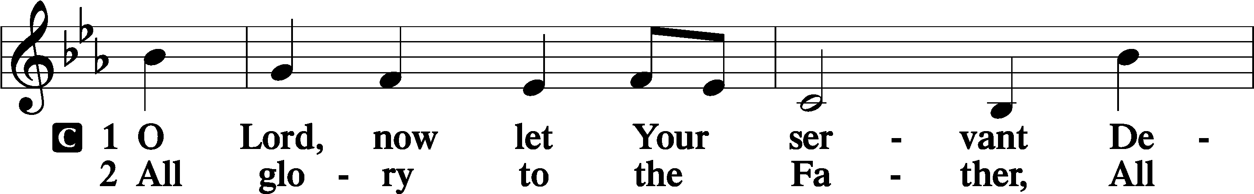
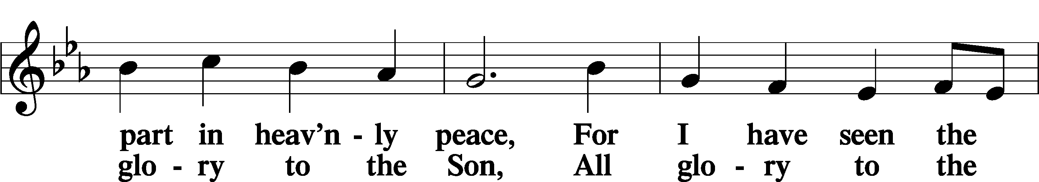
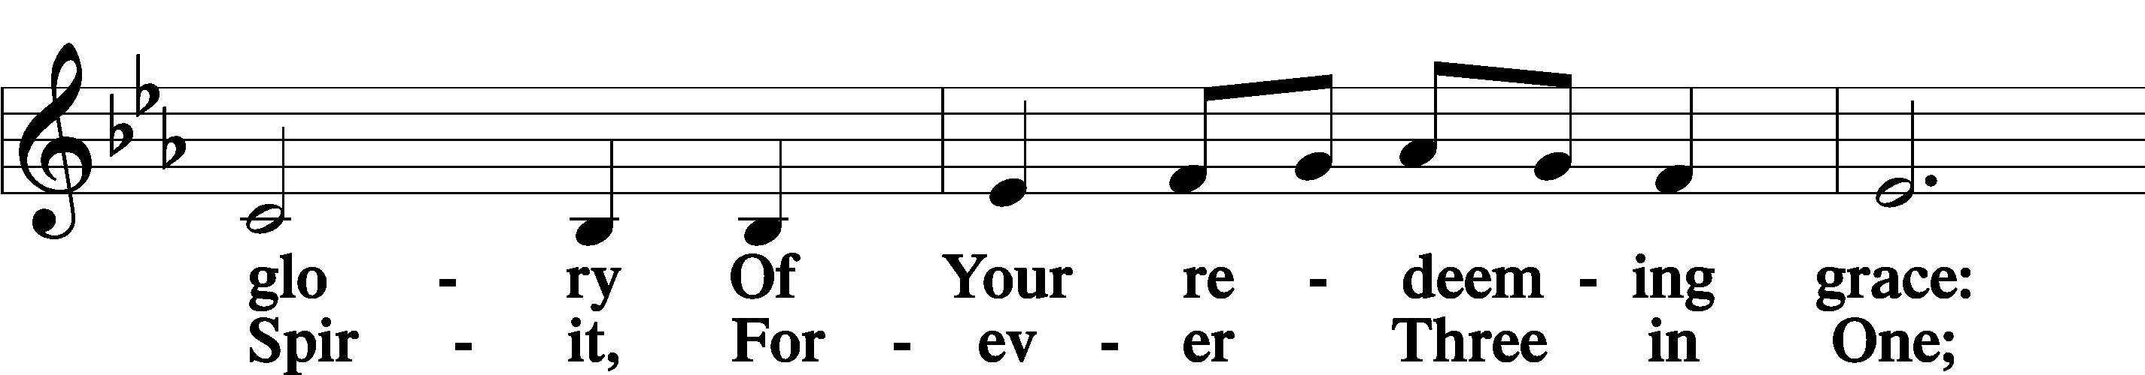
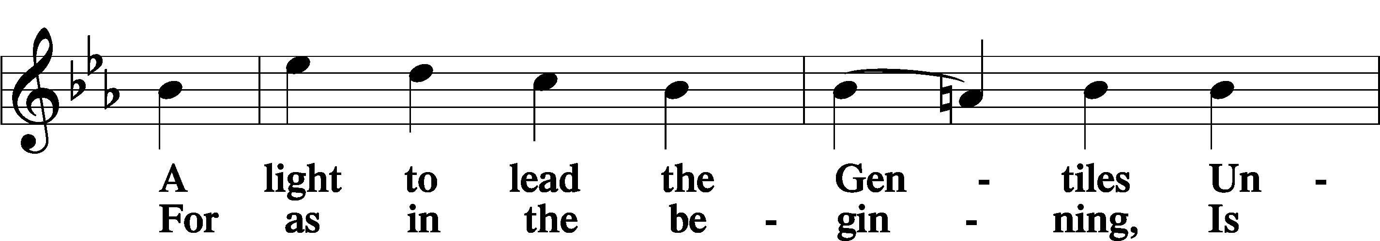
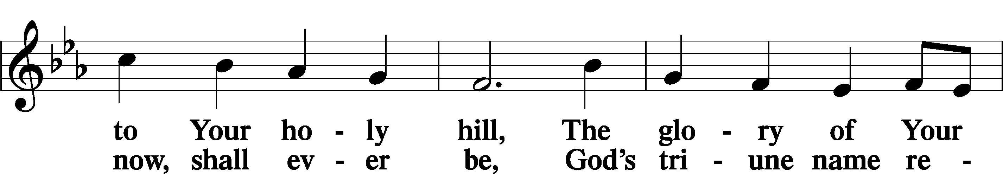
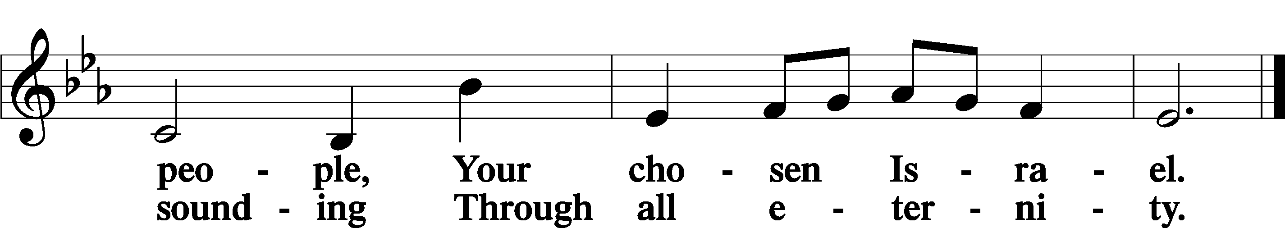

DISMISSAL:
† † †
Go in peace and serve the Lord!

In Christian Service:
All disciples of the Lord Jesus
with
Liturgist: Rev. Walt Pohland
Proclaimer: Rev. Dr. Jim Marriott
Musicians: Adam Perez, Austin Angerman, Joel Marriott, Jim Newkirk, Joann Cotner, Donovan Allen, Kate Thane-Allen
Organist: Rev. Dr. Jim Marriott
8:15 Lay Reader: Melinda Graf
11:00 Lay Reader: Rick Schmidt
Children’s Message: DCE Jonathan Loesch

