Twenty-fourth Sunday after Pentecost
November 12, 2023

Faith Lutheran Church Georgetown, TX 78628
512-863-7332 flcms.org
(The Lutheran Church—Missouri Synod)

WELCOME

INVOCATION:
Pastor: In the name of the Father and of the Son and of the Holy Spirit.
People: Amen.

CALL TO WORSHIP: Psalm 70:1, 4, 51
Pastor: Make haste, O God, to deliver me!
People: O LORD, make haste to help me.
Pastor: May all who seek You rejoice and be glad in You!
People: May those who love Your salvation say evermore, “God is great!”
Pastor: You are my help and deliverer;
People: O LORD, do not delay!
Pastor: Glory be to the Father and to the Son and to the Holy Spirit;
People: as it was in the beginning, is now, and will be forever. Amen.

OPENING HYMN: “Rise, My Soul, To Watch and Pray” (Lutheran Service Book, #663)
Rise, my soul, to watch and pray;
From your sleep awaken!
Be not by the evil day
Unawares o’ertaken;
For the foe,
Well we know,
Is a harvest reaping
While the saints are sleeping.

Watch against the devil’s snares
Lest asleep he find you;
For indeed no pains he spares
To deceive and blind you.
Satan’s prey
Oft are they
Who secure are sleeping
And no watch are keeping.

Watch! Let not the wicked world
With its lies defeat you
Lest with bold deceptions hurled
It betray and cheat you.
Watch and see
Lest there be
Faithless friends to charm you,
Who but seek to harm you.

Watch against yourself, my soul,
Lest with grace you trifle;
Let not self your thoughts control
Nor God’s mercy stifle.
Pride and sin
Lurk within,
All your hopes to shatter;
Heed not when they flatter.

But while watching, also pray
To the Lord unceasing.
God protects you day by day,
Strength and faith increasing,
So that still
Mind and will
Shall unite to serve Him
And forever love Him.
Text: Public domain

CONFESSION AND ABSOLUTION: (LSB, page 151, absolution—left colulmn)
Pastor: Beloved, if we say we have no sin, we deceive ourselves, and the truth is not in us.
People: But if we confess our sins, God, who is faithful and just, will forgive our sins and cleanse us from all unrighteousness.
Pastor: Let us then confess our sins to God our Father.
People: Most merciful God, we confess that we are by nature sinful and unclean. We have sinned against You in thought, word, and deed, by what we have done and by what we have left undone. We have not loved You with our whole heart; we have not loved our neighbors as ourselves. We justly deserve Your present and eternal punishment. For the sake of Your Son, Jesus Christ, have mercy on us. Forgive us, renew us, and lead us, so that we may delight in Your will and walk in Your ways to the glory of Your holy name. Amen.
Pastor: Almighty God in His mercy has given His Son to die for you and for His sake forgives you all your sins. As a called and ordained servant of Christ, and by His authority, I therefore forgive you all your sins in the name of the Father and of the Son and of the Holy Spirit.
People: Amen.

KYRIE (LSB, pages 152-153, chanted)
Pastor: In peace let us pray to the Lord.
People: Lord, have mercy.
Pastor: For the peace from above and for our salvation let us pray to the Lord.
People: Lord, have mercy.
Pastor: For the peace of the whole world, for the well-being of the Church of God, and for the unity of all let us pray to the Lord.
People: Lord, have mercy.
Pastor: For this holy house and for all who offer here their worship and praise let us pray to the Lord.
People: Lord, have mercy.
Pastor: Help, save, comfort, and defend us, gracious Lord.
People: Amen.

PRAYER OF THE DAY:
Pastor: The Lord be with you.
People: And also with you.
Pastor: Let us pray:
People: As we await Your coming, Lor Jesus, we pray that by Your Spirit we may demonstrate such compelling justice and mercy that many people are drawn to Your cross and tomb, there by faith to receive pardon and everlasting life; for You live and reign with the Father and the Holy Spirit, one God, now and forever. Amen.

HYMN: “O Holy Church of God”

O holy Church of God,
hear this prophetic word:
True cross-formed judgments, sealed by blood,
await the coming Lord.

Before time’s final day
all weariness deny.
No yawning slothfulness display
while souls around you die.

Like waters from above
let Christian mercy flow.
Put into action faith’s bold love
that all Christ’s name may know.

Let justice roll to bless
all nations, ev’ry race.
Tell forth by lives of righteousness
the truth of saving grace.

The trumpet soon will blend
with an archangel’s cry.
Christ Jesus will from heav’n descend
His saints to glorify.

The feast will then begin--
begin yet never cease.
The Bridegroom with His bride will reign
in everlasting peace.
Walter A. PohlandSt. Thomas
November 12, 2023 Short Meter

THE OLD TESTAMENT READING: Amos 5:18–24
Woe to you who desire the day of the Lord!
Why would you have the day of the Lord?
It is darkness, and not light,
as if a man fled from a lion,
and a bear met him,
or went into the house and leaned his hand against the wall,
and a serpent bit him.
Is not the day of the Lord darkness, and not light,
and gloom with no brightness in it?
“I hate, I despise your feasts,
and I take no delight in your solemn assemblies.
Even though you offer Me your burnt offerings and grain offerings,
I will not accept them;
and the peace offerings of your fattened animals,
I will not look upon them.
Take away from me the noise of your songs;
to the melody of your harps I will not listen.
But let justice roll down like waters,
and righteousness like an ever-flowing stream.”
Lector: This is the word of the Lord.
People: Thanks be to God.

EPISTLE READING: 1 Thessalonians 4:13–18
But we do not want you to be uninformed, brothers, about those who are asleep, that you may not grieve as others do who have no hope. For since we believe that Jesus died and rose again, even so, through Jesus, God will bring with Him those who have fallen asleep. For this we declare to you by a word from the Lord, that we who are alive, who are left until the coming of the Lord, will not precede those who have fallen asleep. For the Lord Himself will descend from heaven with a cry of command, with the voice of an archangel, and with the sound of the trumpet of God. And the dead in Christ will rise first. Then we who are alive, who are left, will be caught up together with them in the clouds to meet the Lord in the air, and so we will always be with the Lord. Therefore encourage one another with these words.
Lector: This is the word of the Lord.
People: Thanks be to God.

Lector: Please rise, as you are able.
Lector: The Holy Gospel according to St. Matthew, the 25th chapter:
People: Glory to You, O Lord!

GOSPEL READING: Matthew 25:1–13
[Jesus said:] “The kingdom of heaven will be like ten virgins who took their lamps and went to meet the bridegroom. Five of them were foolish, and five were wise. For when the foolish took their lamps, they took no oil with them, but the wise took flasks of oil with their lamps. As the bridegroom was delayed, they all became drowsy and slept. But at midnight there was a cry, ‘Here is the bridegroom! Come out to meet him.’ Then all those virgins rose and trimmed their lamps. And the foolish said to the wise, ‘Give us some of your oil, for our lamps are going out.’ But the wise answered, saying, ‘Since there will not be enough for us and for you, go rather to the dealers and buy for yourselves.’ And while they were going to buy, the bridegroom came, and those who were ready went in with him to the marriage feast, and the door was shut. Afterward the other virgins came also, saying, ‘Lord, lord, open to us.’ But he answered, ‘Truly, I say to you, I do not know you.’ Watch therefore, for you know neither the day nor the hour.”
Lector: This is the Gospel of our Lord.
People: Praise to You, O Christ!

Lector: We confess together our Christian faith, using the Nicene Creed.

CONFESSION OF FAITH: The Nicene Creed
I believe in one God, the Father Almighty, Maker of heaven and earth and of all things visible and invisible.

And in one Lord Jesus Christ, the only-begotten Son of God, begotten of His Father before all worlds, God of God, Light of Light, Very God of Very God, begotten, not made, being of one substance with the Father, by whom all things were made; who for us men and for our salvation came down from heaven and was incarnate by the Holy Spirit of the virgin Mary and was made man; and was crucified also for us under Pontius Pilate. He suffered and was buried.

And the third day He rose again according to the Scriptures and ascended into heaven, and sits at the right hand of the Father. And He will come again with glory to judge both the living and the dead; whose kingdom will have no end.

And I believe in the Holy Spirit, the Lord and Giver of life, who proceeds from the Father and the Son, who with the Father and the Son together is worshiped and glorified, who spoke by the prophets. And I believe in one holy Christian and apostolic Church, I acknowledge one Baptism for the remission of sins, and I look for the resurrection of the dead and the life of the world to come. Amen!

CHILDREN’S MESSAGE

HYMN: “Wake, Awake, for Night is Flying” (LSB, #516)
“Wake, awake, for night is flying,”
The watchmen on the heights are crying;
“Awake, Jerusalem, arise!”
Midnight hears the welcome voices
And at the thrilling cry rejoices:
“Oh, where are ye, ye virgins wise?
The Bridegroom comes, awake!
Your lamps with gladness take!
Alleluia!
With bridal care
Yourselves prepare
To meet the Bridegroom, who is near.”

Zion hears the watchmen singing,
And all her heart with joy is springing;
She wakes, she rises from her gloom.
For her Lord comes down all-glorious,
The strong in grace, in truth victorious;
Her star is ris’n, her light is come.
Now come, Thou Blessèd One,
Lord Jesus, God’s own Son,
Hail! Hosanna!
We enter all
The wedding hall
To eat the Supper at Thy call.

Now let all the heav’ns adore Thee,
Let saints and angels sing before Thee
With harp and cymbals’ clearest tone.
Of one pearl each shining portal,
Where, joining with the choir immortal,
We gather round Thy radiant throne.
No eye has seen the light,
No ear has heard the might
Of Thy glory;
Therefore will we
Eternally
Sing hymns of praise and joy to Thee!
Text: Public domain

SERMON: “Judgement and Mercy” (Matthew 25:1-13)

PRESENTATION OF GIFTS AND OFFERINGS

PRAYERS OF THE CHURCH

THE LORD’S PRAYER:
Our Father who art in heaven, hallowed be Thy name; Thy kingdom come; Thy will be done on earth as it is in heaven; give us this day our daily bread; and forgive us our trespasses as we forgive those who trespass against us; and lead us not into temptation; but deliver us from evil, for Thine is the kingdom and the power and the glory forever and ever. Amen.

PREFACE
Pastor: The Lord be with you.
People: And also with you.
Pastor: Lift up your hearts.
People: We lift them to the Lord.
Pastor: Let us give thanks to the Lord our God.
People: It is right to give Him thanks and praise.

PROPER PREFACE
Pastor: It is truly good, right and salutary that we should at all times and in all places give thanks to You, holy Lord, almighty Father, everlasting God, through Jesus Christ, our Lord, Who, out of love for His fallen creation, humbled Himself by taking on the form of a servant, becoming obedient unto death, even death upon a cross. Risen from the dead, He has freed us from eternal death and given us life everlasting. Therefore with angels and archangels and with all the company of heaven we laud and magnify Your glorious name, ever more praising you and singing:

SANCTUS

WORDS OF INSTITUTION:
Our Lord Jesus Christ, on the night in which He was betrayed, took bread; and when He had given thanks, He broke it, and gave it to His disciples and said: “Take, eat; this is My body, which is given for you. This do in remembrance of Me.”

In the same way also He took the cup after supper, and when He had given thanks, He gave it to them, saying: “Drink of it, all of you; this cup is the new covenant in My blood, which is shed for you for the forgiveness of sin. This do, as often as you drink it, in remembrance of Me.”

PAX DOMINI ~ The Peace of the Lord
Pastor: The peace of the Lord be with you always.
People: Amen.

AGNUS DEI

DISTRIBUTION
The Lord’s Supper will be distributed at the altar rail. Please follow the ushers’ directions.
DISTRIBUTION SONG: “O Come to the Altar”
Are you hurting and broken within,
Overwhelmed, by the weight of your sin?
Jesus is calling.
Have you come to the end of yourself,
Do you thirst for a drink from the well?
Jesus is calling.

O come to the altar;
The Father's arms are open wide.
Forgiveness was bought with
The precious blood of Jesus Christ.

Leave behind your regrets and mistakes.
Come today; there's no reason to wait.
Jesus is calling.
Bring your sorrows and trade them for joy;
From the ashes a new life is born
Jesus is calling.

O come to the altar;
The Father's arms are open wide.
Forgiveness was bought with
The precious blood of Jesus Christ.
(Repeat)

Oh, what a Savior, isn’t He wonderful;
Sing alleluia, Christ is risen.
Bow down before Him, for He is Lord of all;
Sing alleluia, Christ is risen.

O come to the altar;
The Father's arms are open wide.
Forgiveness was bought with
The precious blood of Jesus Christ.
Bear your cross as you wait for the crown;
Tell the world of the treasure you've found.
© 2015Music by Elevation Worship Publishing (Admin. by Essential Music Publishing LLC)
All Rights Reserved. Used by permission: CCLI #1718515
DISTRIBUTION SONG: “What a Beautiful Name”
You were the Word at the beginning
One with God the Lord Most High
Your hidden glory in creation
Now revealed in You our Christ

What a beautiful Name it is
What a beautiful Name it is
The Name of Jesus Christ my King
What a beautiful Name it is
Nothing compares to this
What a beautiful Name it is
The Name of Jesus

You didn't want heaven without us
So Jesus You brought heaven down
My sin was great Your love was greater
What could separate us now

What a wonderful Name it is
What a wonderful Name it is
The Name of Jesus Christ my King
What a wonderful Name it is
Nothing compares to this
What a wonderful Name it is
The Name of Jesus
What a wonderful Name it is
The Name of Jesus

Death could not hold You
The veil tore before You
You silence the boast of sin and grave
The heavens are roaring
The praise of Your glory
For You are raised to life again

You have no rival
You have no equal
Now and forever God You reign
Yours is the kingdom
Yours is the glory
Yours is the Name above all names

What a powerful Name it is
What a powerful Name it is
The Name of Jesus Christ my King
What a powerful Name it is
Nothing can stand against
What a powerful Name it is
The Name of Jesus

What a powerful Name it is
The Name of Jesus
What a powerful Name it is
The Name of Jesus
CCLI Song # 7068424
Ben Fielding | Brooke Ligertwood
© 2016 Hillsong Music Publishing Australia (Admin. by Capitol CMG Publishing)
For use solely with the SongSelect® Terms of Use. All rights reserved. www.ccli.com
CCLI License # 1718515

DISTRIBUTION HYMN: “This is the Feast” LSB, page 155
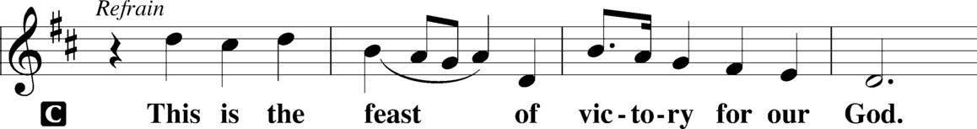
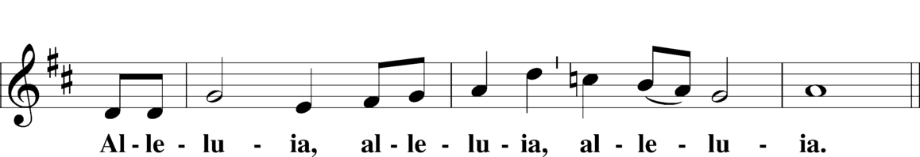
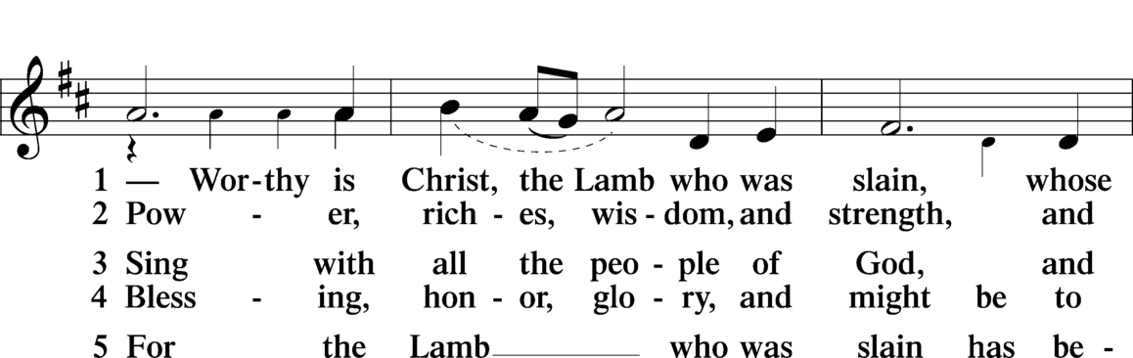
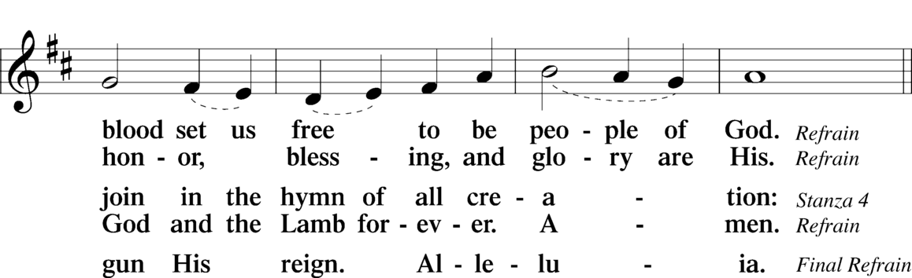
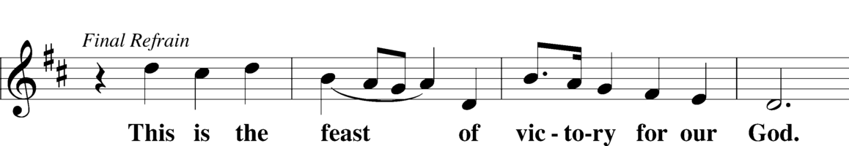
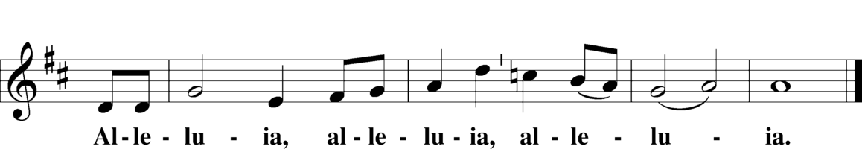

DISTRIBUTION HYMN: “What Is This Bread” (LSB, #629)
What is this bread?
Christ’s body risen from the dead:
This bread we break,
This life we take,
Was crushed to pay for our release.
O taste and see—the Lord is peace.

What is this wine?
The blood of Jesus shed for mine;
The cup of grace
Brings His embrace
Of life and love until I sing!
O taste and see—the Lord is King.

So who am I,
That I should live and He should die
Under the rod?
My God, my God,
Why have You not forsaken me?
O taste and see—the Lord is free.

Yet is God here?
Oh, yes! By Word and promise clear,
In mouth and soul
He makes us whole—
Christ, truly present in this meal.
O taste and see—the Lord is real.

Is this for me?
I am forgiven and set free!
I do believe
That I receive
His very body and His blood.
O taste and see—the Lord is good.
Text: © 1991 Fred and Jean Baue. Used by permission: LSB Hymn License no. 110005093

COMMON DISMISSAL:
Pastor: Now may this true body and blood our Lord Jesus Christ strengthen and preserve you in faith unto life everlasting.
People: Amen.

POST-COMMUNION PRAYER
Pastor: Let us pray:
People: Gracious God, our heavenly Father, You have given us a foretaste of the feast to come in the holy supper of Your Son’s body and blood. Keep us firm in the true faith throughout our days of pilgrimage that, on the day of His coming, we may, together with all Your saints, celebrate the marriage feast of the Lamb in His kingdom which has no end; through Jesus Christ, Your Son, our Lord, Who lives and reigns with You and the Holy Spirit, one God, now and forever. Amen.

BENEDICTION: (Numbers 6:24-26)
Pastor: The Lord bless you and keep you. The Lord make His face shine on you and be gracious to you. The Lord look upon you with favor and give you peace.
People: Amen.

CLOSING HYMN: “The Bridegroom Soon Will Call Us” (LSB, #514)
The Bridegroom soon will call us,
“Come to the wedding feast.”
May slumber not befall us
Nor watchfulness decrease.
May all our lamps be burning
With oil enough and more
That we, with Him returning,
May find an open door!

There shall we see in glory
Our dear Redeemer’s face;
The long-awaited story
Of heav’nly joy takes place:
The patriarchs shall meet us,
The prophets’ holy band;
Apostles, martyrs greet us
In that celestial land.

There God shall from all evil
Forever make us free,
From sin and from the devil,
From all adversity,
From sickness, pain, and sadness,
From troubles, cares, and fears,
And grant us heav’nly gladness
And wipe away our tears.

In that fair home shall never
Be silent music’s voice;
With hearts and lips forever
We shall in God rejoice,
While angel hosts are raising
With saints from great to least
A mighty hymn for praising
The Giver of the feast.
Text (st. 1): © 1982 Concordia Publishing House. Used by permission: LSB Hymn License no. 110005093
Text (sts. 2–4): Public domain

DISMISSAL:
† † †
Go in peace and serve the Lord!

In Christian Service:
All disciples of the Lord Jesus
with
Liturgist: Rev. Walt Pohland
Proclaimer: Rev. Dr. Jim Marriott
Musicians: Adam Perez, Lauren Brezina, and Austin Angerman
Organist: Rev. Dr. Jim Marriott
8:15 Lay Reader: Joanna Roche
11:00 Lay Reader: Matt Cavaliere
Children’s Message: DCE Jonathan Loesch

